**University of Hertfordshire**



**School of Physics, Engineering and Computer Science**

**A Hot tub Price Prediction & Analysis**

**Final Project Report**

Course: Data Science & Analytics with PlacementModule code: 7COM1039-0509-2021

Title: Advanced Computer Science Masters Project

Name: - Kunal Sandip Deshpande

Student id: - 19055288

Supervisor: Dr. Julia Ghoncharenko

**MSc Final Project Declaration**

This report is submitted in partial fulfilment of the requirement for the degree of Master of Science in Advance Computer Science at the University of Hertfordshire (UH).

It is my own work except where indicated in the report.

I did not use human participants in my MSc Project.

I hereby give permission for the report to be made available on the university website provided the source is acknowledged.

**Acknowledgement**:

I would like to take this opportunity to express my respect & gratitude to Dr. Julia Ghoncharenko my supervisor for her assistance in this project. She guided me thorough steps for this research. I am grateful for her time & Guidance.

I also extend my thank to Dr. Mysar Tabany module leader for constant Guidance.

I'd like to thank Gifts 4 All Occasions Ltd. (Mspa UK) for supplying the Hot tub's Sells rating in Placement Year to use in this research.

Finally, I want to thank my parents for their support without them I wouldn’t be able to complete this thesis as their support in my long working hours was incredible.  
  
I am also extending my thanks to British Library London to provide the books, peaceful environment to carrying out research.

**Abstract**

This research study focuses on regression approaches for predicting hot tub prices. The study's purpose is to examine several regression methods on our dataset, such as decision tree algorithm & Random Forest algorithm to discover the optimal pricing to manage prices in the present market. Furthermore, the notion of automated data gathering in a humane manner, Hyperparameter Tunning, and other analyses are applied, and pertinent metrics are validated. Practical work is done in an Anaconda navigator environment on a Jupyter notebook with Python Programming Language.

Table of Contents

Chapter 1: Introduction10-14

1.1 Overview & Problem Definition10

1.2 Research Question & Hypothesis11

1.2.1 Research question

1.2.2 Research Hypothesis

1.3 Aims & Objectives 11

1.3.1 Aim of the research

1.3.2 Objective of the research

1.4 Software Requirements based on different Techniques 12

Table 1.1: Techniques, Software & Tools Used in this research.

1.5 Professional/ethical/legal/ and social issues of the research 13

1.5.1 Legal Contracts & Professional Issue

1.5.2 Law of intellectual property

1.5.3 Law & ethics

1.5.4 Ethics for data

1.5.5 Social issues

1.6 Project Plan14

1.7 Summary14

**Chapter 2: Background Research & Literature Review15-23**

2.1 Worldwide Hot tub market15

2.2 Overview of data16

2.3 Literature Review18

2.3.1 Web scrapping & Application in E-commerce

2.3.2 Quality of Collected Data

2.3.3 Decision Tree Algorithm

2.3.4 Random Forest Algorithm

2.4 Summary23

Chapter 3: Regression Methods24-30

3.1 Introduction to Machine Learning24

3.2 Multivariate Linear Regression 25

3.3 Decision Tree Regressor27

3.3.1 Working of decision tree on hot tub dataset

3.3.2 Why to choose decision tree over linear regression

3.4 Random Forest Regressor29

3.4.1 Working of random forest

3.4.2 Why did research decide to use random forest

3.5 Summary30

Chapter 4: Methodology & Implementation 31- 49

4.1 Implementation Design31

4.1.1 Description of Implementation Design

4.1.2 Key facts to obtained from Implementation design

4.2 Introduction to Tools & Techniques 32

4.3 Data collection34

4.3.1 Data collection method & Implementation

4.4 Data Preparation37

4.5 Step by step Implementation & Feature engineering40

4.5.1 Importing dataset

4.5.2 One hot encoding / Label encoder

4.5.3 Feature selection

4.5.4 Implementation of decision tree algorithm

4.5.5 Implementation of decision random forest algorithm

4.6 Implementation of Evaluation parameters47

4.7 Summary49

Chapter 5: Result & Discussion51-59

5.1 Results51

5.1.1 Distribution plot

5.1.2 Scatter plot

5.1.3 Result of evaluation parameter

5.1.4 Result of behaviour of model

5.1.5. Result of the heatmap

5.2 Discussion56

5.3 Summary59

Chapter 6: Conclusion & Future work60-61

6.1 Conclusions60

6.2 Future work61

Chapter 7: Evaluation62-63

7.1 Self evaluation62

7.2 Key Learnings62

7.3 Project Management63

Chapter 8: Bibliography64-66

Chapter 9: Appendices67-88

Appendix 1: Project plan/ Project management67

Appendix 2: Destined Website for URL69

Appendix 3: Regex Explanation70

Appendix 4: Categorical Variable into Numerical71

Appendix 5 : Implementation of Hubber Loss72

Appendix 6 : Pearson co relation matrix73

Appendix 7 : Result of evaluation parameter in images74

Appendix 8 : Project code75

List of Figures

Figure 1.1 Fluctuations of hot tub market11

Figure 2.1 Cost variance for different types of hot tub16

Figure 2.2 Architecture of Web scrapping19

Figure 2.3 Improved data quality20

Figure 2.4 Decision tree with wrong approach21

Figure 2.5 Decision tree with right approach 22

Figure 2.6 Architecture of random forest23

Figure 3.1 Scatter plot26

Figure 3.2 Ideal linear regression line27

Figure 3.3 Example of node selection28

Figure 4.1 Design of implementation31

Figure 4.2 Data construction flow chart35

Figure 4.3 Implementation code of scrapper36

Figure 4.4 Example use of regex36

Figure 4.5 Implementation of random function37

Figure 4.6 Messy data38

Figure 4.7 Cleaned data39

Figure 4.8 Importing dataset40

Figure 4.9 Use of regular expression40

Figure 4.10 ‘Cost’ vs ‘Make’ visualization41

Figure 4.11 One hot encoding42

Figure 4.12 Feature importance43

Figure 4.13 Implementation of decision tree44

Figure 4.14 Decision tree root node45

Figure 4.15 Decision tree leaf node45

Figure 4.16 Implementation of random forest45

Figure 4.17 Hyperparameter Tunning46

Figure 4.18 Implementation of evaluation metrics48

Figure 4.19 Huber loss formula48

Figure 4.20 Huber loss visualization 49

Figure 5.1 Dist-plot of decision tree51

Figure 5.2 Dist-plot of random forest51

Figure 5.3 Scatterplot of decision tree52

Figure 5.4 Scatterplot of random forest52

Figure 5.5 Overview of the result53

Figure 5.6 Behaviour of model54

Figure 5.7 Heatmap of features55

**Chapter 1**

**Introduction**

**1.1 Overview & Problem definition**

The hot tub market in countries such as the United Kingdom, the United States, and the European Union is always trending because residents of these countries cannot build a swimming pool at home to enjoy the summer. Hot tub gives numerous Health benefits like relief from lower back, stress, Anxiety also people attracted to relaxation (*Hot Tub Market Size, n.d.).*This trend has significantly increased since people are unable to enjoy their summer vacations, so they have decided to spend their summer in their home or garden with family. Section 2.1 can give you a better understanding of the hot tub and its market.

There are various types of hot tubs, each with its own shape, capacity, and arrangement. Furthermore, the price of a hot tub is determined by the weather for the specific week. All these factors contribute to the market's volatility.

Problem Definition: This problem encountered while working as a data analyst on placement. The company is in the retail business and sells hot tubs to various sellers and consumers throughout the UK. It has been observed that due to fluctuations in this market as a result of the aforementioned reasons, it is very difficult for the company to manage the prices on a regular basis and make an appropriate change based on the market because all competitors of company used to change the prices, offers, and marketing for their favour based on the different features & as a result, consumers have more options to switch to another seller of the same brand hot tubs, so manual knowledge and scattered data leads to low sells and poor marketing policy, research decided to address this issue, which will be covered in a separate section of this report.  
  
The below figure (Fig.1.1) depicts the fluctuation(square boxes) of the hot tub prices. It can be analysed that Mspa fluctuate highest between cost of 250 to 1250. while allice garden fluctuates between 0 to 1220 with lowest fluctuation. Flucation can be seen as a number box and all prices has higher fluctuations in this market.

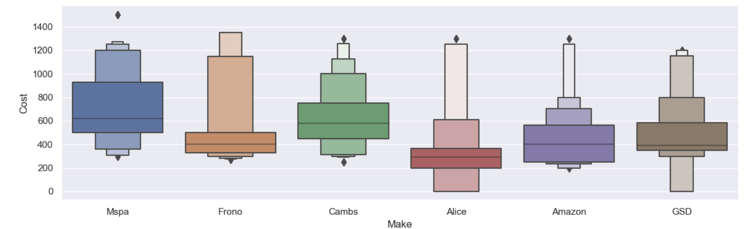

Figure 1.1. Fluctuation of hot tub Market : Comparison plot for fluctuation of cost in hot tub market for different seller. ‘Mspa’ shows Highest fluctuation while ‘Alice’ ends with lowest. (Matplotlib — Visualization with Python, 2022)

This all fluctuations indicates that to sell hot tub for the companies it is essential to have hot tub price prediction to manage the prices daily.

**1.2 Research question & Hypothesis.  
1.2.1 Research Question**

a) Can Decision Tree or Random Forest algorithms provide accurate and feature-based predictions for predicting hot tub prices?

(b) Analysis of different features and categorical data and their importance in predicting price.

**1.2.2 Research Hypothesis**: Spa prices should be fully commensurate with previous spa prices, ratings and specific selling prices based on data. Algorithm of random Forest can be more accurate because of its logical complexity handling capacity.

**1.3 Aims & Objectives**

**1.3.1 Aims of the research**:

Predicting tub costs with supported attributes reminiscent of rating, weather, dates, and associate hot tub sellers by following the market research and automation procedure to collect publicly available information from the websites to get different features with help of SQL Queries also, to create a file which is ready for machine learning  to visualise and use an applicable algorithmic program to analyse the result  predict the prices of the tub.  
  
**1.3.2 Objectives of the research:**

(a) Automating the manual data collection processes to reduce human error and manual actions.

(b)  To only collect publicly available data and follow the legal data guidelines.

(c) Developing a thorough understanding of the various correlations used to generate the final data.

(d) Working on various price prediction algorithms for more accurate predictions, as well as improving marketing policy and sales based on the predictions.

(e) Using a Data Visualization Tool to visualise the data.

**1.4 Software Requirements based on Different Techniques**

|  |  |  |
| --- | --- | --- |
| **Techniques** | **Software Apparatus** | **Tools** |
| Data collection using the scraping/crawling method. | Python 3.8.0, Jupyter notebook | Beautiful Soup, Regular Expression |
| Time series analysis | Python 3.8.0, Jupyter notebook, Matplotlib | Box plot, Bar Plot |
| Data cleaning, Making final Data & Rederiving queries | Microsoft excel, Jupyter Notebook, SQL Workbench | Regular Expression, Excel Function (Trim, Left, Right), SQL queries |
| Regression | Python,3.8.0, Jupyter Notebook | Sci-py, Machine Learning algorithms |
| Data Visualization | Tableau | Data Processing & Presentation |

**Table 1.1**: Techniques, Software & Tools Used in this research.

**1.5 Professional/ethical/legal/ and social issues of the research** : it must consider all the issues before research for real world data as considering all the issues are a Professional approach as a data Scientist For my research, I attempted to address all ethical issues related to legality and the Academic Integrity of University. *(Olga,2021)*

**1.5.1 Legal Contracts & Professional Issue:** This research is not linked to any individual, business, or organisation, either directly or indirectly, with whom it requires legal binding to use data or software, as all are licenced versions and open-source software so there are no legal or professional issue.

**1.5.2 Law of Intellectual Property:** No Copyright content or data is used in this study. This research requires the gathering of information from various websites, in which a programme collects various information from the destination website, which any person in the world can also view by going on that specific URL. If the programme fails to collect the data in the initial request, no further requests will be sent to collect that information. This study makes no use of any person's personal information or copyrighted images. This research paper completely secures intellectual property law of each & every human.

**1.5.3 Law & Ethics**: This research adheres to all the ethical guidelines established by the Academic Integrity Council of University of Hertfordshire. Following the guidelines established by the university is also a research law. This study contains no copyrighted content, forged references. This study will always respect data protection and secrecy. For the purpose of Human Evaluation, this research will always respect human morals. *(Academic Integrity and Academic Misconduct, 2021)*

**1.5.4 Ethics for Data:** Maintaining data ethics is critical for data science students. The automation tool to collect data will only collect information which is available for everyone in public. This information will be used solely for educational objectives. Commercial uses or any kind of uses are strictly forbidden and will not be considered. This research Strictly follows the General Data Protection Regulations which is applicable in UK from 2018 This research paper declares to use public data by law of fair & Transparency (GOV.UK.,2018)

**1.5.5 Social issue:** Since this project will not include any person's name, personal information, or political issue, it does not cover any social issue. Please keep in mind that because this project has no human faces, it does not require ethics approval.

**1.6 Project Plan**

Project planning is very essential to achieve the outcomes & answering the research question Please see Appendix 1 for project plan. This project plan includes Main task of the research and important dates.

**1.7 Summary:**

In this chapter of research focus was on base of the whole research. Points overviewed are

* Problem Statement
* Research question & hypothesis
* Aims & objectives of research
* Software Requirements
* Legal aspects
* Project plan

Next chapter will focus on the Background of hot tub market & will consider the already done work as literature review for this research.

**Chapter 2  
  
Background Research & Literature Review**

This chapter provides a brief overview of the hot tub market and its various aspects. chapter will also examine the dataset that will be used in this project, will also look at the features that are required to sell the hot tub which will help to choose to consider work & Finally, discussion of various related & considered work that attempted to study in the early stages of the project as a literature review.

**2.1 Worldwide Hot Tub Market**

The hot tub market has grown rapidly in the years following 2020. This market is expected to grow at a compound annual growth rate of 9-10% over the next several years *(Maida, 2022)* The primary reason for the market's growth is the current situation in which people are less socialised but still want to spend quality time with their families. People are still afraid to socialise with other people. In this situation, a hot tub provides all the luxury & Health Benefits that a person desires.  
  
There are both fixed and inflatable hot tubs. These two hot tubs are widely available on the market. This hot tub can be used for both personal and commercial purposes. In some countries, having a swimming pool is impossible due to weather conditions, so consumers choose different hot tubs that are easy to move and pack in extreme weather conditions. Nowadays, an inflatable hot tub fulfils that need because they are relatively affordable, easy to pack and maintain, and everyone wants to make their garden more beautiful They also receives various health benefits such as weight loss, stress reduction, diabetes recovery, and skin purification. *(Raj, 2022)* This includes all the benefits that consumers receive at reasonable prices in the market.

As previously stated, the market is rapidly expanding, and Europe's contribution to the hot tub market is expected to be around 40-45% by 2025 *(Maida, 2022)*. However, some political situations outside of Europe have an impact on the energy security of the European and UK regions. This gives the consumer time to consider the alternative of Fixed & Costly hot tub. This factor influences and brings about various saturations in this industry, including various features that influence the price of the hot tub. Which is available to see in the data set's section 2.2. Regardless of the energy security issue, people buy hot tubs to support their physical and mental well-being during difficult times. This all creates a situation in which the prices of hot tubs must be managed daily, so all companies attempt to manage their prices on a weekly basis. This research will Consist of The Price Prediction of the MSpa Hot tubs in uk. It is important for to Co-relate Different Features & Prices.

**2.2 Overview of data / dataset**

This section will provide an overview of the dataset after collection. The dataset for this study was obtained through the scraping of different sellers publicly available information from websites. In the following chapters methodology explained in detail.

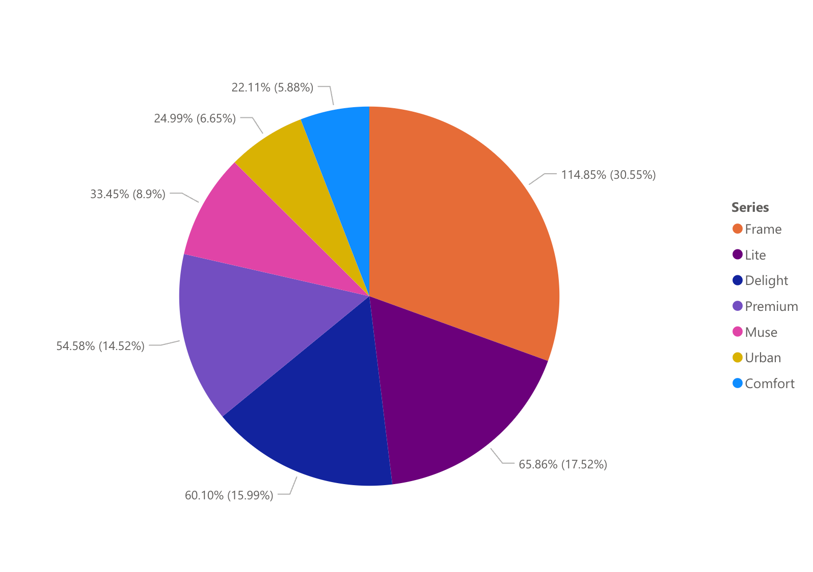

Figure 2.1.Cost variance for different types of hot tub: Cost variance seen higher in Frame series(orange) & lowest in comfort series(blue).(Diagram created in tableau with research dataset).

Above Pie chart (Fig. 2.1) depicts that Frame series consist of highest cost variance with 30.55% while comfort is lowest with 5.88%.while delight shows around 54-55% of Price variance.

Every cost is determined by the various features of the hot tub and is classified as above(Fig. 2.1)

* Make (Name of the seller/competitors of product)
* Date (Date of the scrapped information)
* Series. (Different Types of Mspa Hot tubs)
* Time (Time of the scrapped Information)
* URL (URL of the product)
* Title (Name of the hot tub associated in the series)
* Rating (Sells Rating of the hot tub)
* Weather (Weather of the Mentioned Date)
* Shape (Shape of the hot tub based on available Information)
* Cost (Price of the Hot tub)

The features listed above are the results of scraping various publicly available data sources. I have chosen some of the features that are price related to the price Prediction of the hot tub. Please refer Table 2.1 for a thorough understanding of the dependent and independent variables.

|  |  |
| --- | --- |
| **Independent Variables** | **Dependent Variables** |
| * Make * Date * Series * Title * Rating * Weather * Shape | * Cost |

Table 2.1: Role of the variable in prediction of prices.

as previously stated, this data set(Table 2.1) is crawled and collected from various websites. The raw collected file is sloppy and unclean. This file was cleaned using Regex, Excel cleaning, to create the final data set  
  
**2.3 Literature Review:**

This section will divide the main goal into sections and attempt to consider the previously completed work and its techniques as a literature review.  
  
**2.3.1 Web scrapping & Application in E-commerce**

There are billions of web pages available on the internet, and the average person generates a large amount of data. The internet is used by people to expand their businesses. Thousands of products are uploaded to the internet on a daily basis. If a new company wants to contribute to the global market, they should have a single database of products uploaded to various websites. Web scraping ‘used’ to copying data from a website and dumping it into a personal file (manual process) in previous centuries. *(Henrys, 2021).* It should be noted that this method is time-consuming and ineffective. In this data-driven world, it's useful to have an automated tool that can navigate to the desired website and collect the scripted information for Market Research. It should be noted that automated web scraping is the best way to collect accurate data such as reviews, advertisements, and campaigns. This type of automated data collection tool (Fig. 2.2) can be useful for making market research comparisons *(Upadhyay, Pant and Bhasin, 2017).*

It can be Critically argued that several challenges must be addressed during the web scraping process. *(Upadhyay, Pant and Bhasin, 2017)*

1. Inhumane requests to collect the data can overload the website.

2. Inhumane requests may result in a Captcha or security question before launching the web scrapper, which may cause the scrapper to fail.

3.Before beginning a project, legal and ethical concerns must be addressed. (Which this research has addressed in above section 1.5)

If this issue can be resolved a scrapper will be a godsend for an e-commerce data analyst.

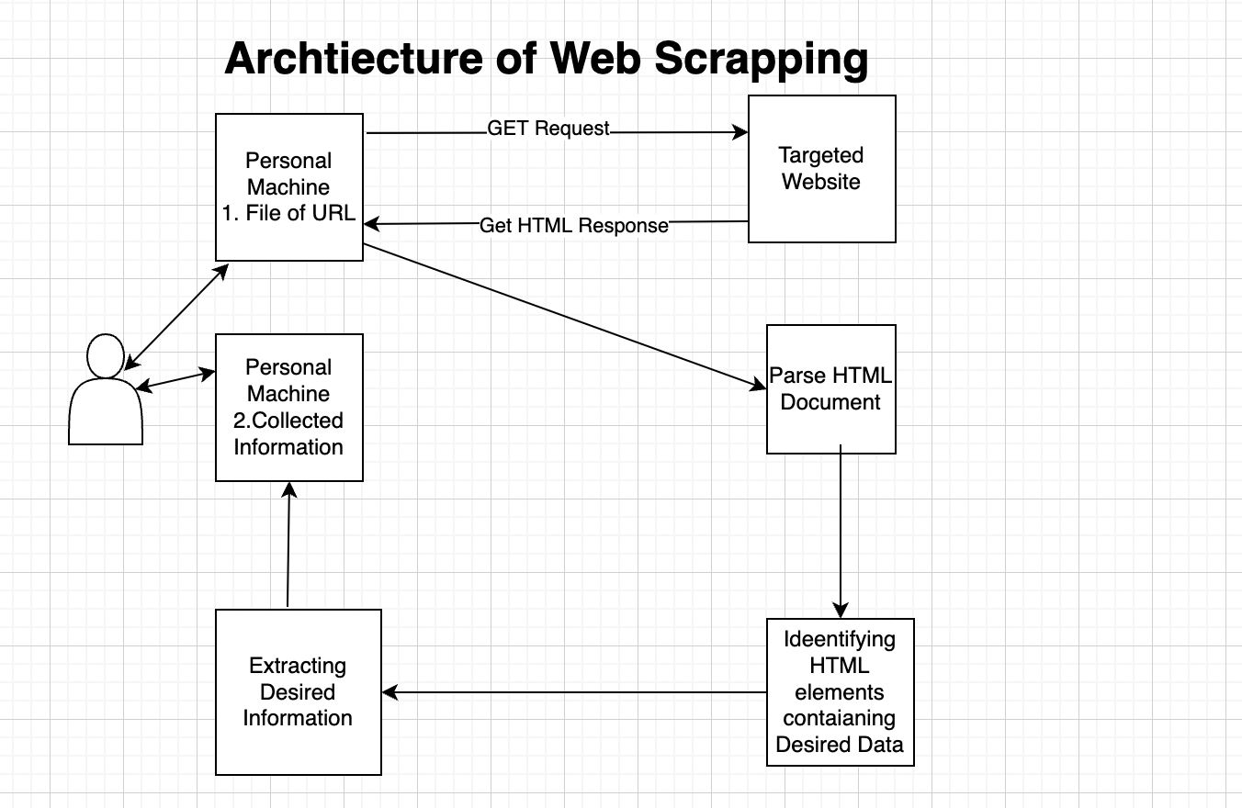

Figure 2.2.Architecture of web scrapping: Figure of Process from collecting information from given URL to dumping in it in excel.(Upadhyay, Pant and Bhasin, 2017).

Above figure(Fig.2.2) Depicts a architecture from collecting URL from excel to Sending a GET Request to targeted website to get HTML where user can work on html document & only identifying HTML element containing Desired data to extract that data & dump it to a local computer. This will be implemented in Methodology.

**2.3.2 Quality of Collected Data:**

As research collected data from various websites, it discovered that different websites have different formats, styles, quality, and features. Any prediction algorithm must convert those differences in expected input quality. Some methods for dealing with messy or cleaned data have improved over the period. Many organisations use a lot of data, but the data outside of the organisation is 85-90% unstructured, while half of the data inside the organisation is Unstructured *(Kiefer et al. (no date, p.2)).*

The definition of unstructured data varies depending on the audience. Humans or computers can make up an audience.

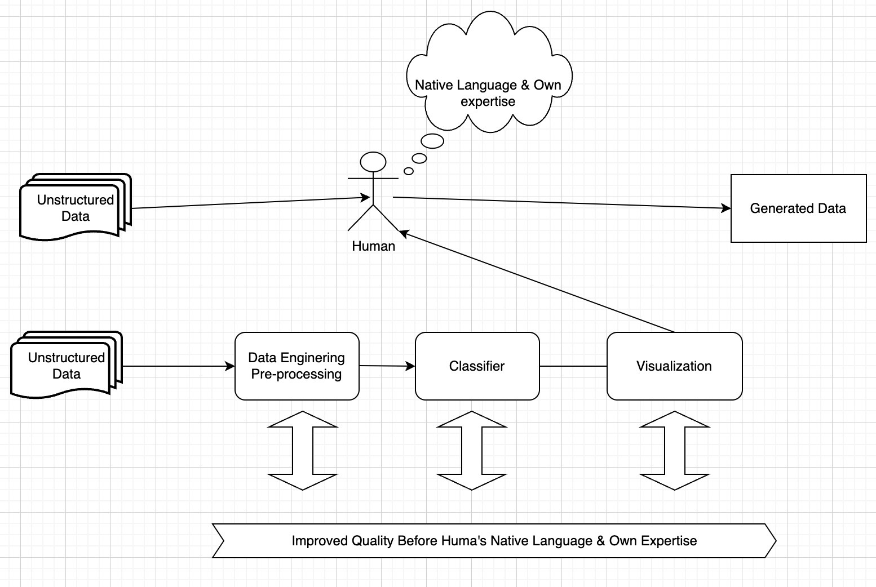

Figure 2.3.Improved Data quality: Figure depicts an improved data quality by giving the Unstructured data for processing before humans. *(Kiefer,2022)*

Figure depicts that if human is required to judge an unstructured database, the human can make decisions based on a variety of factors such as their experiences, human knowledge, and so on. If the machine must decide the quality of unstructured data, it employs a variety of methods for measuring features. It can be visualize & By Processing can improve human understating as well to maintain quality of data with machine(Figure 2.3).

This is the primary reason why data quality is affected by numerous factors for machine. Although, there are Indicators to measure the quality of data including Relevancy of data & accuracy of data for the Machine. *(Kiefer et al. (no date, p.7)).*

However, accessing quality data and structuring it can cause some issues. As an example, unstructured data is vast and can be useful for various vast applications to gain insight. Considering incorrect Features for accuracy can result in limited use and fewer insights. However, when used correctly and precisely, it can produce stunning result.

**2.3.3 Decision Tree Algorithm**

Data mining was the best technology for analysing data in the 20th century but analysing large amounts of data is difficult for data engineers, so big data analysis is required. Decision Tree Algorithm is the best solution for data mining classification and prediction

decide, it capture the best information as a root node and then make the subsidiary information as a leaf node. It uses a greedy top-down approach to classify and predict the algorithm *(Zhong,2016).* This review consists of Decision tree on classification as it is necessary to understand the basic logic of Decision Tree, will see Decision tree Regression in Chapter 3.

This Algorithm employs the Tree or Rule approach. If the data is too complex, neither approach is useful, and use of puring techniques to avoid unnecessary complexity. One of the best and most logical algorithms is ID3 Algorithm. This algorithm makes two assumptions: the leaf node is either positive or negative, and the entropy is always S[Entropy], Please follow the Formula 2.1 Entropy Always Indicates the Purity of an Algorithm(T, 2019) For example, if Feature F1, F2, F3 depends on the Result F. node must consider least complexity.

*Entropy(S). = - $\sum_{i=1}^{n}{ (F_{i} log{ F}_{i})}$ (2.1)*

Where, S is Entropy of dataset containing n features , Fi is frequentist probability of an element.

node must find the purity of the algorithm to select the correct node using formula 2.1. Impurity & purity of algoritham shown below as an example to understand above formula.(Figure 2.4 & Figure 2.5).

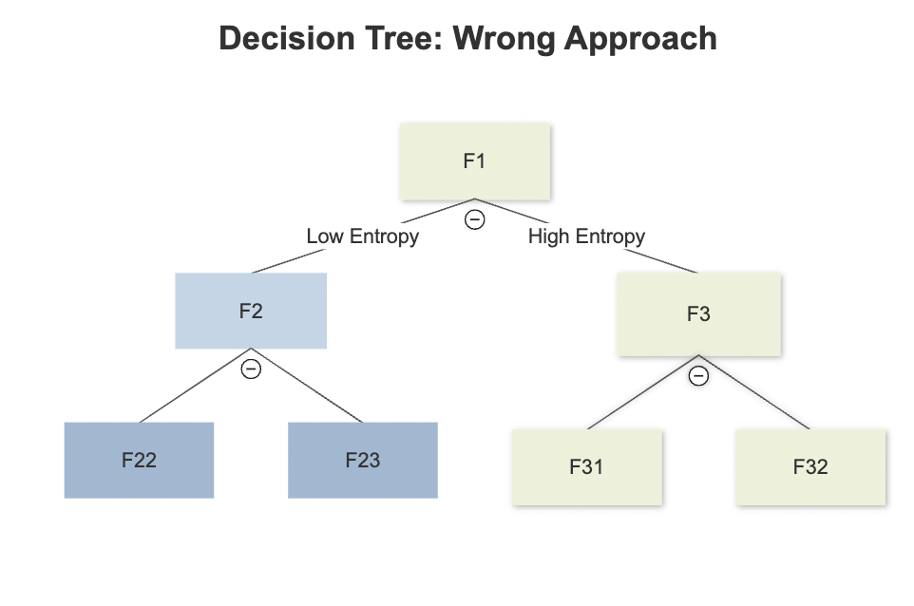 **Figure 2.4**. Decision Tree with wrong approach: Figure of decision tree Choosing node (Green) with High entropy as per(Formula 2.1). (Image Source:“Self”)

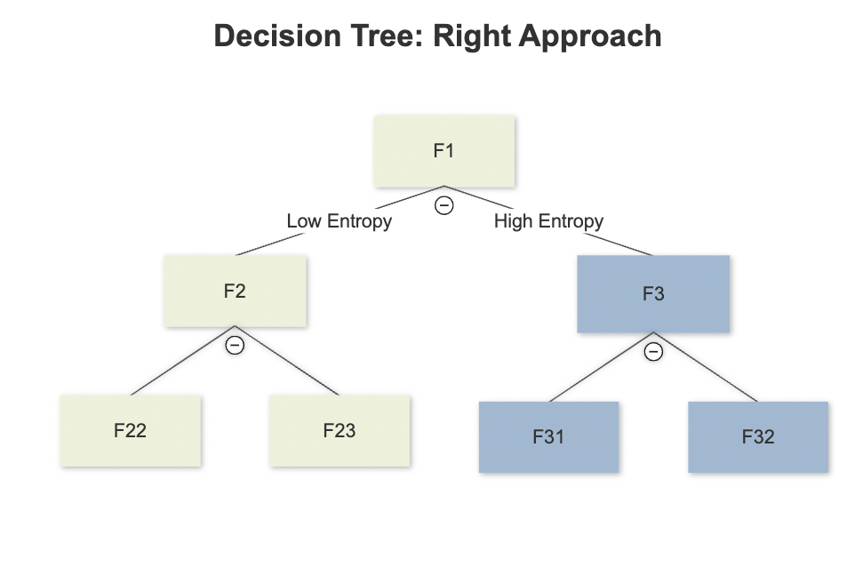  
**Figure 2.5.** Decision Tree with Right Approach : Figure of decision tree Choosing node (Green) with low entropy as per (Formula 2.1) (Image Source:“Self”)

**2.3.4 Random Forest Algorithm**

This is one of the most recent algorithms that can be used for regression and classification. The Random Forest Algorithm is a combination of various decision tree algorithms in which each decision tree contributes to the decision-making process until the depth is reached. There are dependent(y) and independent variables(x) available in the random forest as well. Please refer to Formula 2.2 for a more thorough understanding, Figure 2.6 can also help to understand the random forest algorithm *(Liu*et al.*, 2012, pp. 246-252).*

*S(x) = argmax $\sum_{i=1}^{N}{I}$ (Si(x)=Y) (2.2)*

*Where, S(X) is the combination of model, Si is single decision tree.*

Formula 2.2 Explains the *Si(x)=y(Number of independent variables are with dependent variable and sum of all decision tree’s Maximum vote is output.)*

Random Forest algorithm is also Useful for the regression in the spaces of x random variables for output y All the properties still work same as classification. Difference is it used average of all decision tree for output.*(Liu*et al.*, 2012, pp. 246-252).*

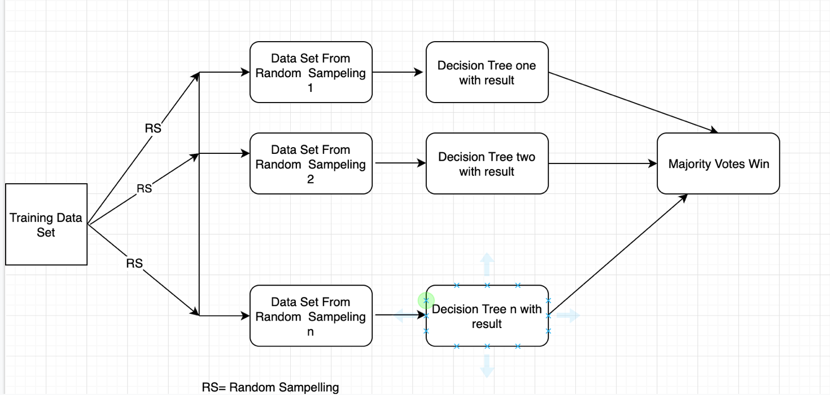 **Figure 2.6.**Architecture of Random Forest: Sending a random sample to different Decision Tree to get a output with majority votes of decision tree*(Liu*et al.*, 2012, pp. 246-252).*

The original data set is divided into various random trees, as shown in the figure Above. Every Decision tree will receive random samples from the algorithm. All samples will go through different sections of the decision tree.(Fig.2.6) & will cast their vote in classification Problem and majority vote will be the decision that random forest will make.

However, this algorithm has a significant disadvantage in that it contains too many trees, which causes it to make ineffective and inaccurate predictions for real-time data. random sampling may miss features in real-world. However, it will be interesting to see whether or not this algorithm performs better on this research’s dataset.

**2.4 Summary**

This Chapter focused on some of the Interesting thing

* Background Information of Hot tub
* Overview of Dataset to choose related work
* Literature Review / Considered work

This chapter can conclude that no prediction algorithm was made for hot tub price prediction, but it will be good to see which pros and cons will work for the feature of hot tub on hot tub dataset. It will be interesting to see algorithms will perform better and if yes which algorithm will give accurate result.

**Chapter 3**

**Regression Method**

This chapter will provide a brief overview of machine learning and the role that regression will play in determining hot tub prices. Every method has its own set of rules and variations, which will be addressed in this chapter using hot tub dataset as the foundation of research. Please keep in mind that study will go over dataset collection and the methods in greater detail in the following chapters, but it is critical to go over regression methods so it will end up with the choice of method at the end of this chapter.  
  
**3.1 Introduction to Machine Learning**

Machine learning is the study of algorithms, tools, and techniques that allow a machine to learn a thing based on different factors. This learning is primarily divided into three parts, as shown below. (Selig, 2022)

**Unsupervised (Unlabelled):** Thislearning entails using a system to discover inputs, outputs, and hidden patterns from training data which is unlabelled, such as Clustering methods and Dimension Reduction.

**Supervised(labelled):** This machine learning technique, the user provides input, and the machine predicts the outputs based on the input and training data. For example, Classifier and Regression.

**Reinforcement**: This is the process by which a machine learns to maximise rewards & Minimise errors by generating input in the current environment. Best example is Giving a cube to a robot to solve.

Primarily concentration should be on regression because i need to calculate the prices of independent variables that have a continuous value that regression can predict. Let’s move on to the next section of this research because most of this information has already been studied somewhere, and this research will try to find the best insights from data and discover something that can help to find and establish new concepts of ideas.

**3.2 Multivariate Linear Regression**

The linear regression model is a popular technique that can be used to address a variety of issues in the current industries, anticipate future trends, and establish a causal relationship between various variables because this is also a research question, so let's look at data as an equation.

The data set contains a variety of variables. Table 2.1 shows the independent and dependent variables. Assume there are Y dependent variables that are dependent on the feature X= (X1, X2 ...Xm) T independent variable in the vector A so fitting linear regression using the algorithm will look like equation 3.1*(Maulud et al., 2020, pp. 140-147)*

$y\left(X,A\right)=\sum_{i=o}^{M-1}{A_{i}F_{i}}(X)+ϵ$ (3.1)

Here, X is the independent variable of dataset in vector A. where ,Fi(X) is the basis function, M is the number of basis function, were $ϵ$ is the noise term. If $ϵ$ is zero it means function is linear & equally derived. For the Multivariate let’s Try to write this equation is simple format so it will be

$y=A_{0}+A_{1}X_{1}+.....A_{M}X_{m-1}+ϵ$ (3.2)

Equation 3.2 is descriptive equation of 3.1. it is visible that how the Multivariable data will look like when multivariable data set will come into the equation.

Where, $y=\left[\begin{matrix}y_{1} \\ y_{2} \\ . \\ . \\ y_{N}\end{matrix}\right]$, X= $\left(\begin{matrix}X_{11} & X_{12} & ... & X_{1M} \\ X_{21} & X_{22} & ... & X_{2M} \\ ⋮ & . & ⋱ & ⋮ \\ X_{N1} & X_{N2} & ⋯ & X_{NM}\end{matrix}\right)$, A= $\left[\begin{matrix}A_{1} \\ A_{2} \\ . \\ . \\ A_{M}\end{matrix}\right]$

As visible in equation (3.2) *(Maulud et al., 2020, pp. 140-147).* where dependent variable y is totally dependent on the value of X and vector A, need to make sure that dataset is following all the rules to get fit in the equation I can analyse the formula and can see if data fit to equation.

**1**.**Linear relation**: There should be a linear relationship between the independent and dependent variables, as shown in equations 3.1 or 3.2, where the value of y increases as the value of X increases.

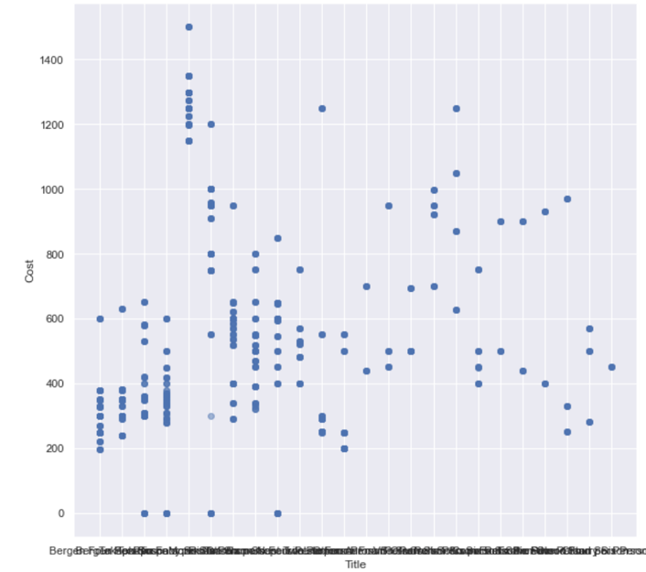

Figure 3.1. Scatter Plot : Scatter plot of Independent variable & dependent variable shows a scatterness showing nonlinearity on hot tub dataset (Matplotlib — Visualization with Python, 2022)

Scatter Plots depicts the relation between Independent variable Title (X-axis) & cost(y-axis) where data points showing relation between them. As this Figure (Fig 3.1) shows high scatterness & outliers it can be proven that relation is non-linear.

**2.Variation**: When creating linear regression in the graph, some of the points will be far from the regression line. This method generally makes many regression lines using Least squared method to fit. This will Increase the Time complexity of the algorithm. Please see ideal linear regression line below (Fig 3.2) which will give the less Mean absolute & mean squared error (Distance between actual data point & predicted data point).

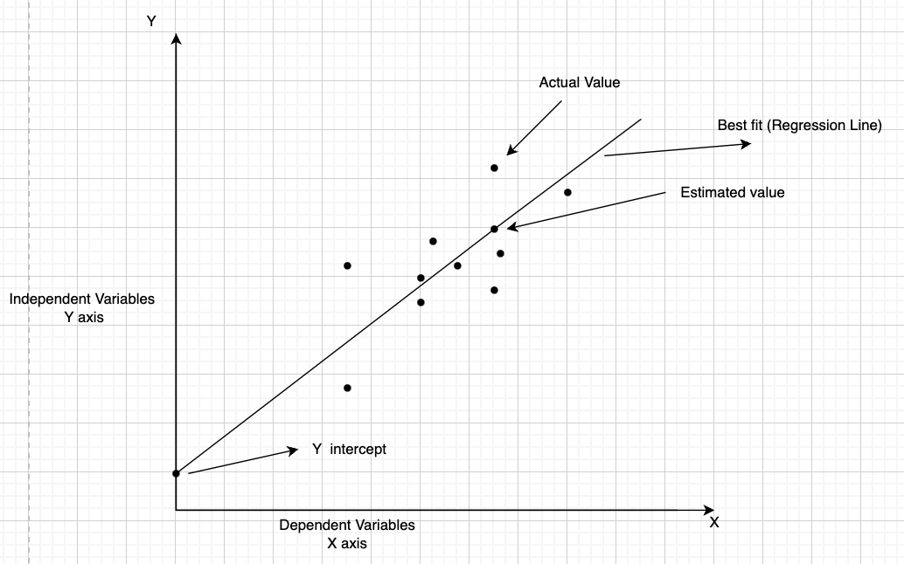

Figure 3.2.Ideal linear regression line: Graph of Ideal linear regression line between independent(X-axis) & dependent Variable(Y-axis) (Chelliah, 2021)

Ideal regression line is the best fit line for model between Actual & estimated value for linear regression.as mentioned above (Fig 3.2). This relation is only possible when relation of the variable is linear. (Chelliah, 2021)

Hot tub data is unfit for linear regression and if linear regression is performed it will give inaccurate data, high ratio of error. Please follow ideal linear regression line(Figure 3.2) which line is hard to imagine on nonlinear scatterplot.(Fig. 3.1).This research about algorithm shows that this study needs to choose the algorithm which can build logical relation with independent variables.

**3.3 Decision Tree Regressor**

**3.3.1 Working of Decision tree on Hot tub dataset**Decision Tree Regression is logical and can handle all of the drawbacks that linear regression cannot. This section will look at regression. As it is available in 2.3.3 ,the classification decision tree algorithm uses entropy to determine which node should come next, whereas the regression algorithm uses variance and a technique called variance reduction. Let’s try to understand it using a formula.

Let’s consider Y dependent variable on features X whereas seen before there is no linearity, please refer Table 3.1. Please note that developed example is based on the Nature of this research’s data set of hot tub

|  |  |  |
| --- | --- | --- |
| independent Feature X1 | Independent Feature X1 | dependent variable |
| X11 | X21 | Y1 |
| X12 | X22 | Y2 |
| X13 | X23 | Y3 |
| X14 | X24 | Y4 |

**Table 3.1:** Table of Independent & dependent variables .showing relationship between both variables

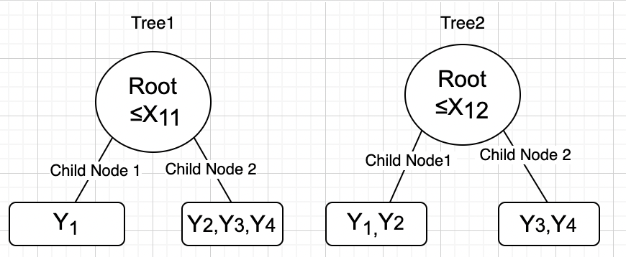

Figure 3.3. Example of node selection: Root node & its relationship with child nod.

Above figure mentioned root node(X-independent feature) is associated with leaf nod (Y-dependent feature) (image source: “Self”)

Let’s Consider two root nodes X11 & X12 Where test data is asking for output Y with condition of lower related value of X. Please see Figure 3.3 for example root node condition with possible output. Let’ see how this algorithm will decide which node to go with by variance in equation 3.3. (Sharma, 2020)

Variance(V) = Mean Square Error = 2  (3.3)

Where, N is the number of independent features in dataset,

$y_{i}-\overline{y}$ is difference between true y and the mean which is known as residual.

Based on this formula Tree calculate the variance of root node & both the child nodes and try to find the variance reduction with formula .

Variance Reduction (VR)= Variance of root node(V) - $\sum_{i=1}^{N}{W_{i}}$ (Variance of child node) (3.4)

This Variance reduction calculated for Tree1 & Tree2 as shown in the figure based on equations. If the VR (Variance reduction) result is VR1(Tree1)< VR2(Tree2) then decision tree chooses Tree2 to proceed further as it reduces the variance & giving less Mean Squared Error & giving accurate result to proceed the tree. This method accurately shows how the node getting selected in regression.

**3.3.2 Why to choose decision tree algorithm over Linear regression?**

* This algorithm can handle categorical data more efficiently, and Hot Tub data set contains a large amount of categorical data, which can also converted to numerical by encoding for a better result.
* Because this algorithm looks for and finds linearity based on logic rather than just regression lines, co-linearity between independent features is also considered for output. This is critical for hot tub dataset.
* Because of the variance reduction method, it can reduce noise or variance, allowing it to handle noise better.
* All these factors led this research to select Decision Tree for this research project.

**3.4 Random Forest Tree Regressor**

**3.4.1 Working of Random Forest**As visible in Figures 3.1 data is dispersed based on different features, making it important to comprehend the feature importance technique that Random Forest can offer. Random forest is one of the key algorithms in any machine learning techniques. Please Refer to figure 2.6. Once the various decision tree has received random samples. The decision tree operates in much the same way as the decision tree regressor described in section 3.3.1. The same principles apply to random forest regression, with the minor exception that random forest regression uses the average of the majority value rather than the majority value itself as the outcome of the Majority classifier.

**3.4.2 Why did research decide to use Random Forest for this study?**

* It gives various decision trees a random sample.
* It offers and enables the feature selection of the features.
* It accepts any fresh updates to the data.
* It adheres to each of the 3.3.2 points.

**3.5 Summary:**

The purpose of this chapter was to choose the best regression approach for this research based on the characteristics of own data set.

* It is concluded that linear regression is a not a suitable technique since it produces a lot of error and noise.
* Decision trees and random forests can provide with better & logical prediction.

**Chapter 4**

**Methodology & Implementation**

This chapter will provide a brief overview of methodology and its implementation to the research questions to achieve the aims and objectives. This chapter will also provide the Implementation Design of this Research and will proceed through all sections in accordance with the research design.

**4.1 Implementation Design**

It is essential to review the methodology implementation design. Figure 4.1 depicts the Implementation Design specifically created for this research.

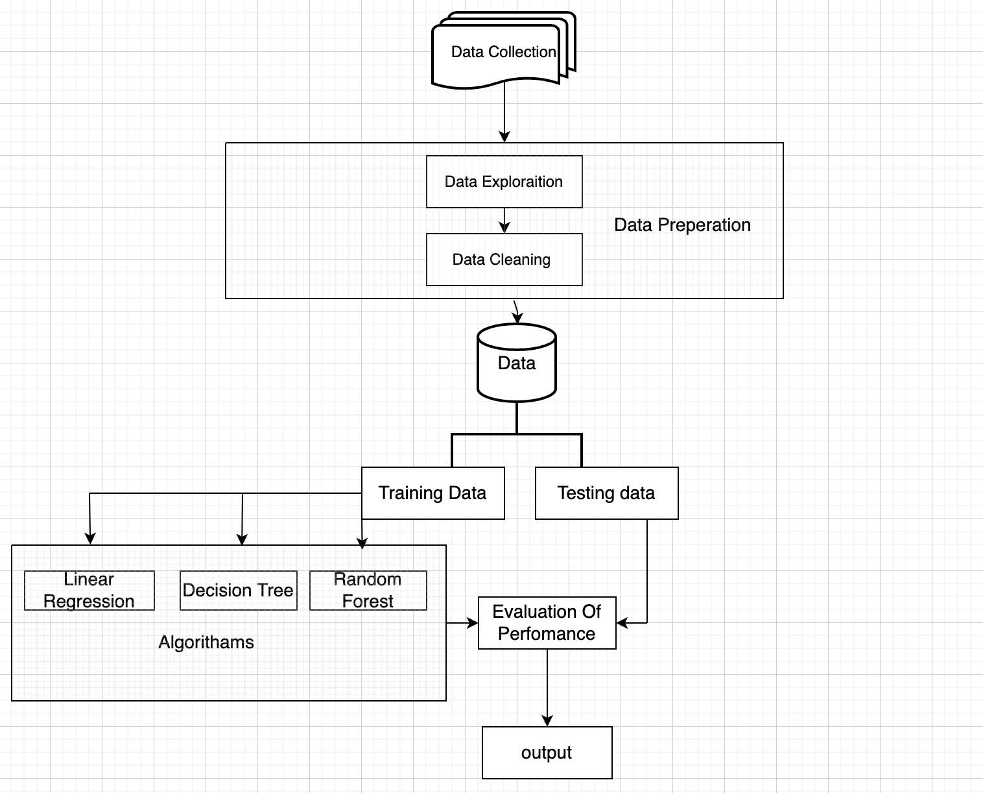

Figure 4.1. Design of implementation: Includes step of data collection, data Processing & working on different Machine learning model to evaluate the outcome of obtained the result. (Source: “Self”)

**4.1.1 Description Of Implementation Design**: This architecture was created specifically for the implementation of this research, which takes a top-down approach. The flow of the figure explains data collection. Collected data must pass through various data preparation methods before being fed to machine learning algorithms and obtaining the output to evaluate performance. This chapter will adhere to this agreement to comprehend the Implementation and Design. (Figure 4.1)

Please keep in mind that this implementation design is scalable, reliable, maintainable, and adheres to a conceptual integrity of this research.

**4.1.2 Key facts To obtain from implementation Design for this study**

* Opening-up the research implementation structure of this study.
* Considering all phases prior to implementation for this research
* Functional requirements noted.
* An overview of the communication between various blocks.

**4.2 Introduction of Tools & Techniques**

**Python**- Python is a high-level programming language that may be used for machine learning, web pages, and other innovative technologies. This is an open-source programming language that includes complete data analysis features. (Geek, 2022)

**Jupyter Notebook**: Jupyter Notebook is a web application that allows you to create programming documents. It is also handy for viewing the output of various cells. & Visualizing it. (Jupyter, 2022)

**NumPy-** NumPy is a scientific Component tool that is useful in Python. It allows to do all mathematical operations, handle arrays, and manage mathematical components that may import using the 'import NumPy' command. (NumPy, 2022)

**Pandas-** Panada is one of the Python libraries. This enables to examine, clean, and perform several operations on the data collection. It also allow to see a big amount of data and draw mathematical conclusions from it. (W3school,2022)

**Sklearn** – Scikit-learn is known as a complete machine learning package because of its different machine learning techniques.it is open source and available as python package.it is useful as medium level for Supervised or unsupervised learning (Pedregosa et al. 2011)

**Regular Expressions**: Regular expressions are used to identify patterns in strings, and by recognising patterns, it may perform data cleaning tasks. Regular expression re is a built-in package that can imported for regular expressions. (Dib, n.d.)  
  
**Beautiful Soup**- Beautiful Soup is one of the libraries for parse a structured data. It interacts with numerous html tools and can be used for working on received html. It contains certain methods, such as the prettify() function, for making received html more user friendly. (Python, n.d.)

**SQL -** Structured Query Language is useful for maintain, create, delete or work on any database. some software like SQL workbench is also useful for visualizing that data. (Geeks, 2022).

**Matplotlib-** Matplotlib provides an amazing visualisation by importing matplotlib (Matplotlib — Visualization with Python, 2022).

**Seaborn**: Seaborn is library under matplotlib for more ,amazing & attractive visuals in python.

**Selenium**: Selenium is a webdriver specifically used in web automation (WebDriver, 2022)

**Seaborn**: Seaborn is library under matplotlib for more ,amazing & attractive visuals in python.

**4.3 Data collection**Data collection is the first step in beginning of research project. This chapter will briefly discuss the methodology and its implementation.

**4.3.1 Data Collection Method & Implementation**

There are several methods for collecting data, but This method of collecting data from the scrapper because this data collection method will be useful for hot tub market research, and this will collect all publicly available information from different hot tub sellers to analyse prices.

**Web scraping Method**: This is a conventionally used technique for extracting useful information from web pages by automating the tool Please refer Figure 2.2. This study will use the same architecture to extract information from various web pages. Where my crawler will go to the URL By sending GET request and receive HTML in response so crawler can render to Desired HTML & can obtain desired information to store in Excel/Sql Please keep in mind that this methodology has some drawbacks. Similarly, to how inhumane requests can be declined and data cannot be collected, the HTML of the targeted page can change over time. In the following section, this research will attempt to address the entire web scarping issue.

**Tools & Techniques for web scrapping**: Beautiful soup, Regular Expression, Selenium, Excel.

**Implementations**: Let’s divide implementation into three sections.

* Collecting URLs
* Creating an Automated Scrapper (automated data collection)
* Dumping data in excel

Please see Figure 4.2 below for a more detailed explanation of how Scrapper will collect data.

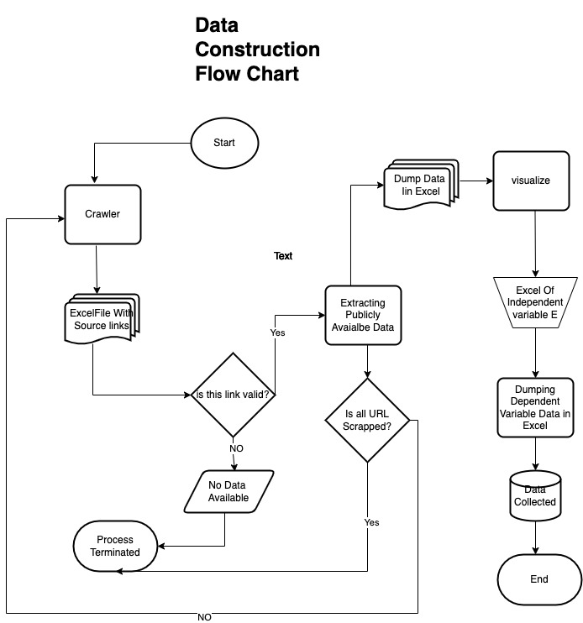**Figure 4.2.** Data construction flow chart :Includes a Process of Data collection From collecting URL to dump that data in Excel/Sql for data processing. (Source: “Self”)

diagram depicts the lifecycle of Scrapper Where my crawler moves to excel file of source link & it collects the data of Source link if source link is valid then it dump that data in excel/sql where data processing can be applied. This section will see the Implementation of the whole construction flow chart

**Collecting URL**: Please keep in mind that, to achieve research goals, I must manually collect the various URLs of seller of hot tub' websites in separate Excel files. Because no organisation changes their URLs every year, collecting URLs will save a lot of time in the future.

Please see Appendix 2 for the links of the targeted website for collecting publicly available hot tub information.

**Creating an Automated Scrapper**: Please refer figure 4.3 below for the Implementation Programming of scrapper.

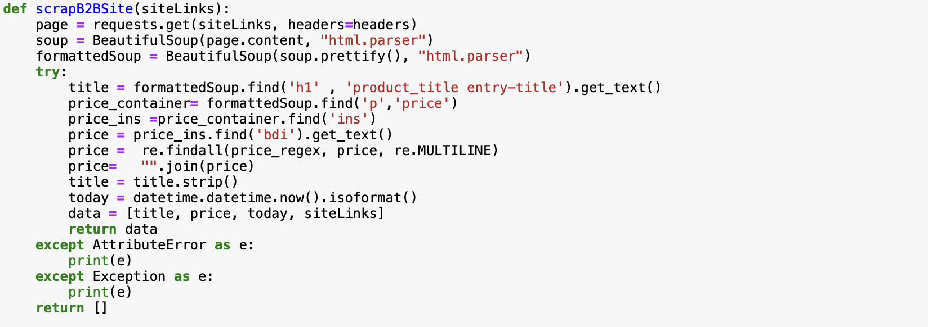

Figure 4.3.Implementation code of scrapper : collecting desired HTML using method of beautiful soup. (Source: “Self”)

Figure depicts that Soup method makes readable HTML by using. Prettify() method. Readable HTML can be be found using find() method (Fig 4.3) variable named price_ins) which allow scrapper to render to destined information. Where it can store Title, Price ,URL ,Date & time from datetime.now() method.(Fig 4.3).

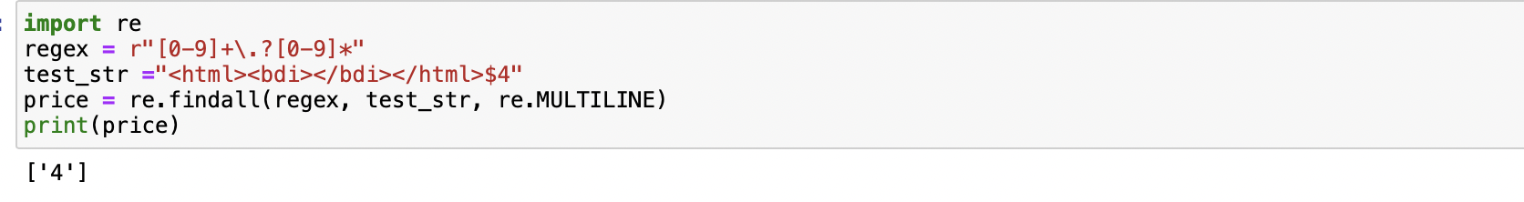

Figure 4.4.Example Use of regular expression :to remove the extra space from the collected data (Image Source: “Self”)

code depicts that regex variable working on every incoming html variable to remove the spaces from ‘Price’ to give a non-spaced output.(Fig 4.4)This regex can be created in regex101 (Dib, n.d.).

**Dumping Data in Excel/Sql & use of Random function:** Please refer Figure 4.5 for the implementation of random variable

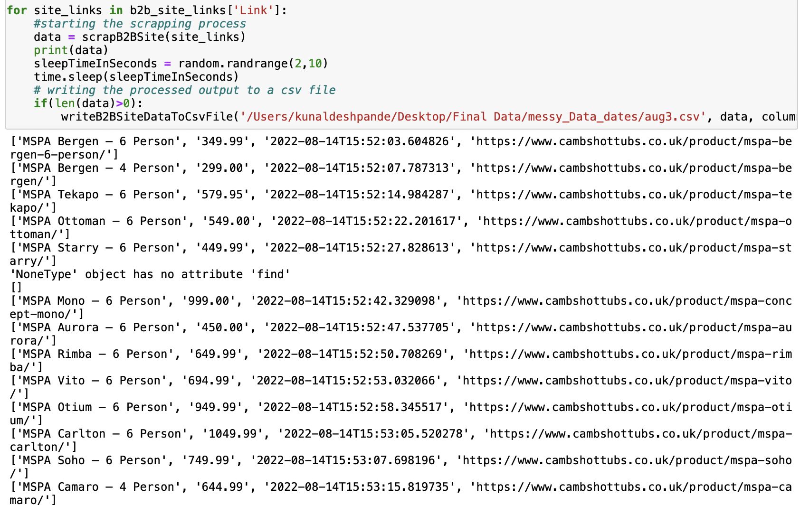

Figure 4.5: Implementation of random Function : sending a humane request & dumping a data in Excel/sql. (Image Source: “Self”)

Figure shows the use of random function where random.randrange(2,10) sending a request to the destined website in every 2,10 seconds. For making it in more Humane manner which is providing output with all necessary scrapped information. of hot tub. Above (Fig. 4.5) depicts a output of scrapper which getting dumped into csv file by using conventional dumping method of DatatoCsv().

**4.4 Data Preparation**

Data preparation is the fundamental step that can be used to feed data to an algorithm, and it is divided into three stages, which will discuss in this section. Please keep in mind that data preparation is an ongoing process that must be repeated after each data collection.

* Data Cleaning
* Data planning

**Data Cleaning:** Data Cleaning is one of the important task that need to taken care of as uncleaned or messy data can result in disastrous problems, time & efficiency. Data cleaning can be done by two techniques

1. Excel function

2. Regex

**1.Excel function**: There are many excel function canbe used but mainly excel function is useful for removing extra spaces, delete extra character, removing duplicates ,use of the find & replace to clean the data. (Bansal n.d.) this research mostly used the following function

* Trim function: which removes the extra spaces and gave the cleaned no spaces column. Formula of trim is =Trim(Cell number).
* Left/Right Function: This function used to delete any extra symbol from left or right side. Formula for this function is =LEFT(Cell no,[number of characters])/ =RIGHT(Cell no,[number of characters]). (Bansal n.d.)

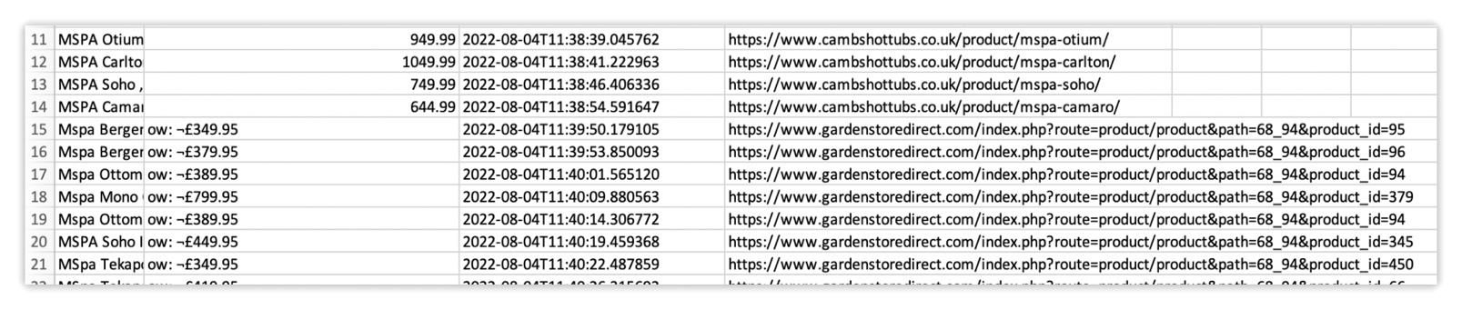

Figure 4.6.Messy data: The figure’s row 15-21 shows a messy data (Second column of prices) before using excel function in the collected data of Dated 04-08-2022(Image Source: “Self”)

Above Figure (Fig 4.6) depicts those rows between 15-21 has a messy collected prices like “ow:-£349.95” for the collected date on 4th August 2022 .This clearly shows a messy & unstructured data.

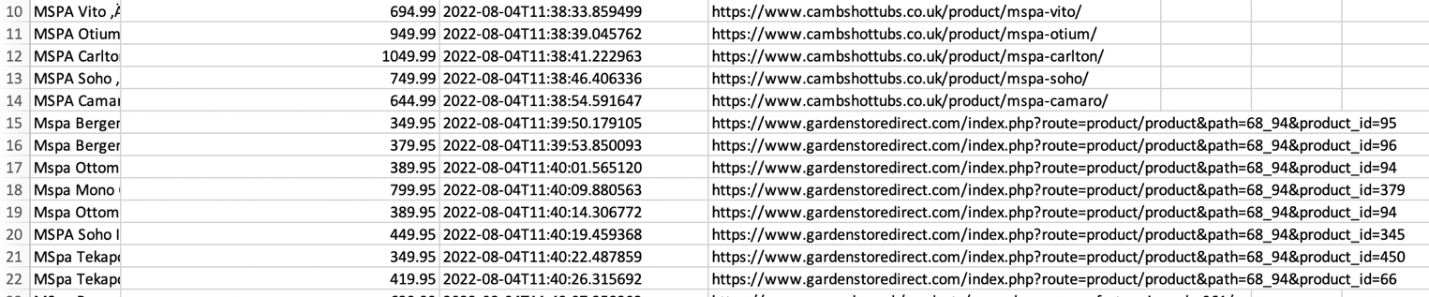

*Figure 4.7.* Cleaned data: The figure’s row 15-21 shows a cleaned data before using excel function in the collected data of Dated 04-08-2022 (Image Source: “Self”)

Above Figure (Fig 4.7) depicts that rows between 15-21 has a cleaned data after using excel function prices are like 349.95 from “ow: -£349.95”. This is kind of data algorithm can accept.

2.Regex*:* This is one of the libraries that can be imported from “re”, an external API regex101 (Dib, n.d.) as previously explained. Sometimes the column name has an unrecognized space, which cannot be removed using the excel function that regex can accomplish for the entire dataset.

For example, if there is a 'cost' column with spaces typed in it as 'cost ‘ machine will handle both differently, and after using Excel functions, this type of space also does not go, thus this study utilized the following regular expressions as an example to remove those spaces.

Please follow appendix 3 for the code block of regular expression.

**Data Preparation process**

Every time data is scrapped, it needs to perform many operations again and again after each data collection process, but this is not a time effective process, so this research must use a time saving approach. After the first data collection, what itgenerated is all the independent variables from the previous scrap and extra variables like rating and shape will be entered in one specific way, and will use the same block every time & will update new dependent variable(cost) only in making of final data.

This data is ready to to feed the machine learning algorithm

4.5 Step by Step Implementation & Feature engineering

This section will see the algorithm implemented step by step with some visualisation to understand what is going on with the process. Final Data which will be used a training data. This algorithm will be implemented in an open source jupyter notebook.

**4.5.1 Importing Data Set**: This Practical work is done on jupyter notebook of anaconda environment so it is important to load the dataset in Jupyter notebook

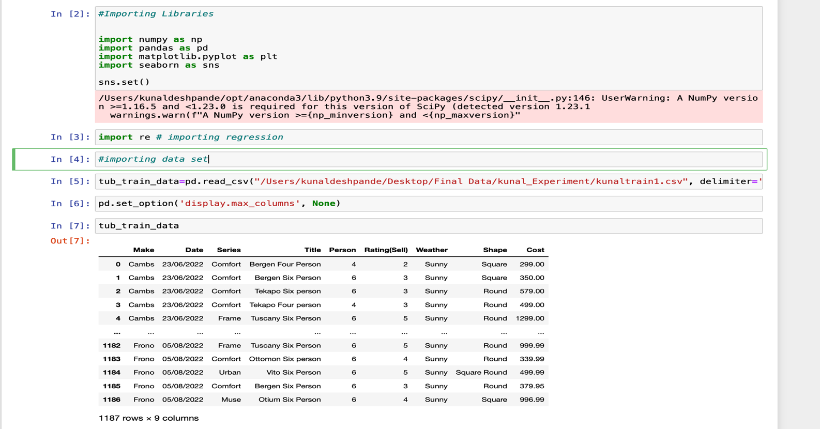

Figure 4.8: Importing dataset: importing csv of collected processed data using the read_csv function (Available in library of pandas) (Image Source: “Self”)

Importing a dataset from csv file is crucial step as above (Fig .4.8) passing a Local path of computer to Jupyter notebook will pass all the data to jupyter notebook which can be seen as well. Moreover ,set_option method will help to display all the columns. Please refer (Fig. 4.8).

Even after the clean data, it is critical to employ a regular expression. The usage of regular expressions assists in removing the impureness of importing data into a Jupyter notebook.

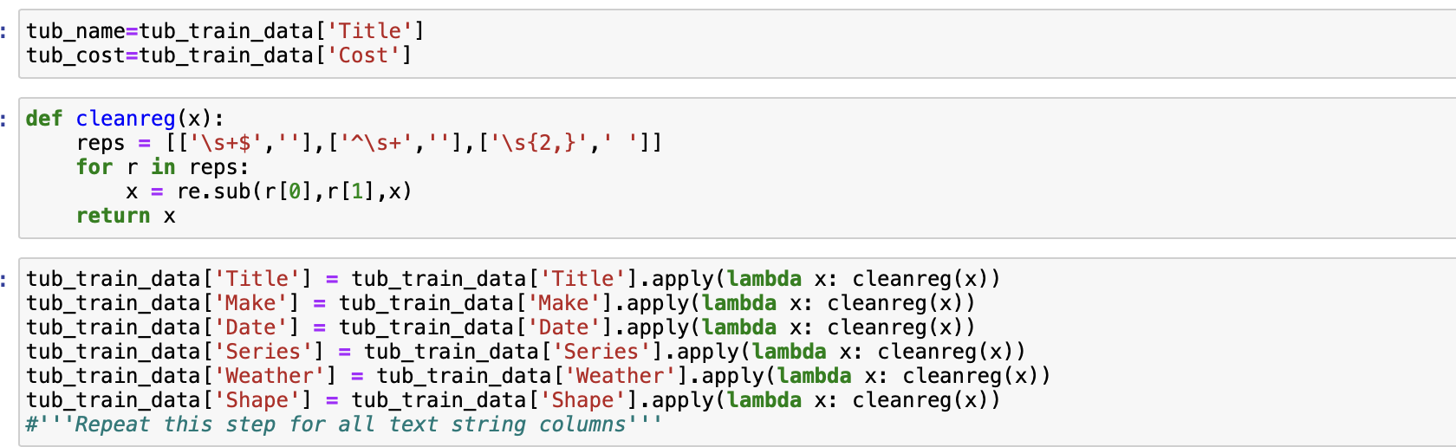

Figure 4.9. Use of regular expression: regular expression function to clean the imported data in jupyter notebook for different features. (Image Source: “Self”)

The above figure(Fig 4.9) illustrates that a function named Clean regex has been created which states all the formatting this study want data cleaning for & same function is passed to all the feature by using method apply(). Please note that creating regex is more of experimental task. This task is carried out on official Regex repository regex101. (Dib, n.d.)

**Visualization of imported data:**

It is critical to see the data that have imported into jupuyter notebook since it will give an idea for the next step and allow to explore the data in new ways.

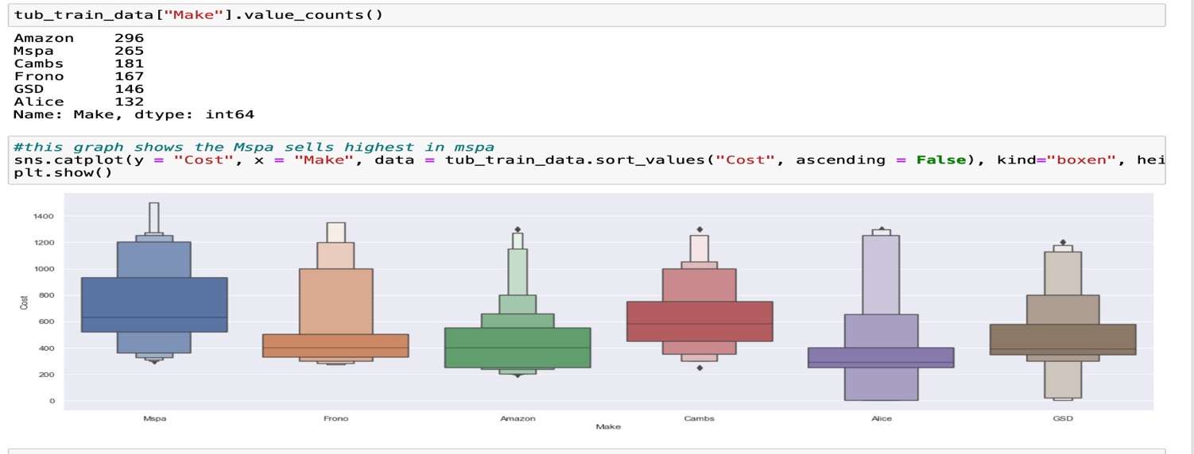

Figure 4.10. Cost vs make visualization: A cat plot of range 0-1400 on y-axis showing fluctuations (Number of Boxes) for different seller of the hot tub Mspa(Blue box) shows highest fluctuations with second highest counts. (Image Source: “Self”)

Fluctuations are crucial when considering data insights since they determine the range of an independent variable. The figure above (Fig. 4.10) displays value counts for each vendor. Although the word "Amazon" appears 296 times in training dataset, the prices on Amazon fluctuate only moderately. Figure 4.10 shows that the fluctuation ratio increases as the number of boxes increases. While Alice Garden (purple box) displays the lowest fluctuations, MSPA (blue box) displays the highest number of boxes with the highest fluctuation.

**4.5.2 One Hot Encoding/ Label Encoder**

There are different number of features, and it need to transformed into the data that machine can understand. Generally, machine handles numerical data and it is very easy if it can be converted in numerical data. It can be achieved using label encoder or one hot encoding using sklearn libraries.

**One hot encoder**: process of converting categorical data into the numerical data.

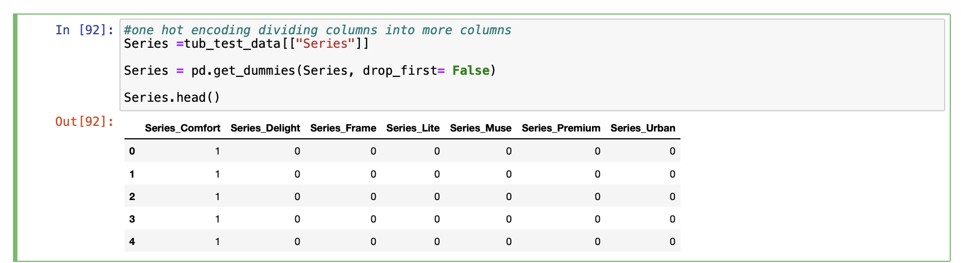

Figure 4.11 one hot encoding: Example implementation of one hot encoding of categorical data “series” using get_dummies method to convert in numerical data. (Image Source: “Self”)

This is the process to convert a categorical data into numerical data and it replace the categorical data with 0’s & 1’s and divide different features into multiple features.as it is visible above (Fig. 4.11) feature ‘series’ has number of categorical data but after performing get _dummies method (one hot encoding) This feature divided into more columns in 0’s &1’s. this is one hot encoding which replaces the original categorical data.

**Label Encoder:** Label encoding is the process of giving a label to a small variety of data e.g. There is feature called a ‘weather’(in hot tub dataset) It can be either sunny or cloudy so it can be labialized as a ‘0’, ‘1’, ‘2’. Function named Label Encoder () can be implemented. It is available under Sklearn. Please refer 4.2 for understanding of Sklearn.

Please see Appendix 4 to see how I dealt with each variable to convert them into numerical.

**4.5.3 Feature selection:**

As seen in the previous part, research used label encoding to enable to access numerous columns; as a result, the complexity of the columns and the number of columns grew; it is critical to identify the relevant features of distinct columns of data.

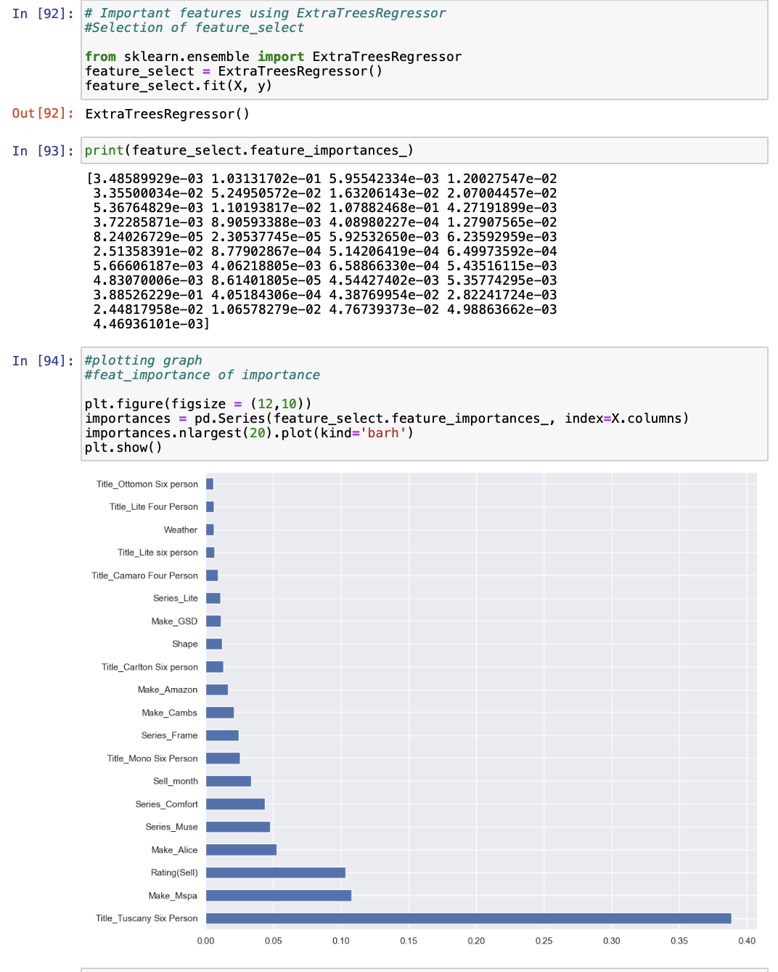

Figure 4.12. Feature importance: Selection of feature using Extra regressor from sklearn to get the Importance of feature & its visualization using Matplotlib showing Tuscany’s higher importance. (Blue Bars). (Image Source: “Self”)

Above figure shows an implementation of feature importance using feature_importance method. (Fig. 4.12) from the Extratreeregessor of sklearn module Please refer section 4.2 for more detail on sklearn. Visualization bar shows a higher importance to Tuscany six person.

**Analysis of Feature Importance**  
as seen above (Fig .4.12). it can be depicted that Title Tuscany _Six_ Person has the most importance, It is visible that Tuscany is the most expensive hot tub prices, and the Comfort Series is the least expensive.(Based on research dataset) If feature significance is looked carefully, Tuscany is the most important from the frame series, while Ottoman is the least important from the comfort series. This leads to the conclusion that tree regressor selects the optimal feature importance.

**4.5.4 Implementation of Decision Tree Algorithm:**

Methods for the decision tree is already examined in chapter 3. This section will provide the implementation of Decision tree algorithm

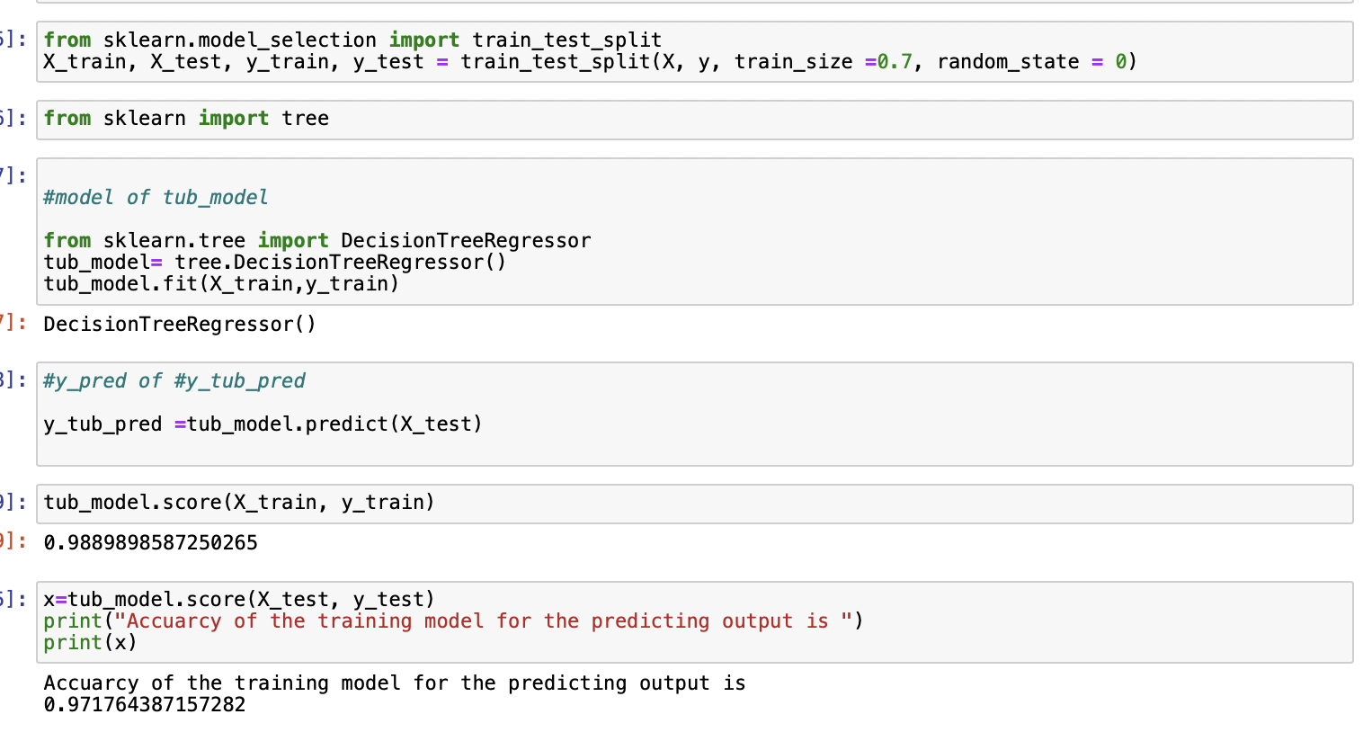

**Figure 4.13.** Implementation of decision tree : figure illustrates implementation of decision algorithm where 70% training data is provided to algorithm to get trained Using Sklearn libraries.(Image Source: “Self”)

The algorithm is implemented by (Fig. 4.13) dividing training data into 70% and validation data into 30%. I tried 40%, 50%, and 60% validation for training data but discovered that 30% validation is the correct size to compare with the outside file of test data to avoid underfitting and overfitting. This implementation is possible because of the split function in the sklearn libraries. 2011 (Pedregosa et al.)

**Visualization of decision tree:**

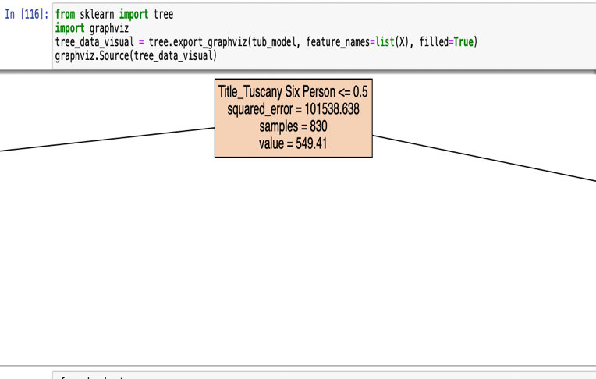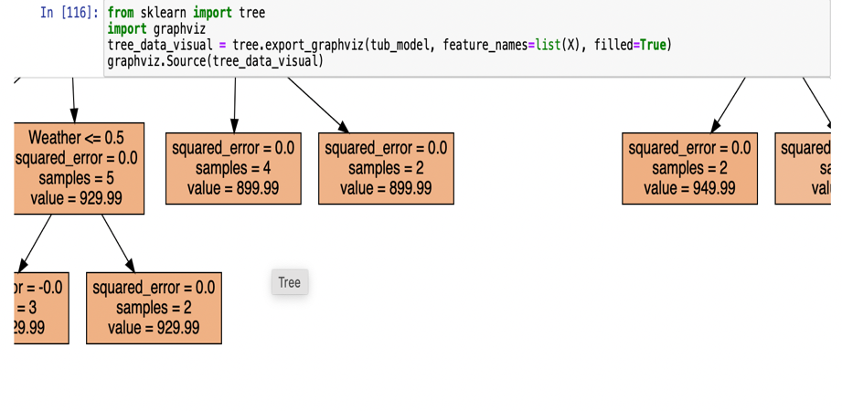

**Figure 4.14**: Decision tree root node: **Figure 4.15**: Decision tree leaf node:

Decision tree root node showing Decision tree leaf node showing zero

high mean squared error.(image source: “self”) mean squared error. (image source: “self”)

Above figure (Fig. 4.14) illustrates the decision tree's root node, which is the Tuscany frame series, which validates idea of feature significance. As visible from the Feature importance, the Tuscany Frame series importance is higher, and have that as a root node here, indicating that this research’s study theory is related to the implementation. This point has a larger Squared error since it is far away, and the initial node is located far away from the original point. Please refer (Fig. 4.15) which has a very low squared error, which indicates that the model is approaching its final nodes and will anticipate the results.

**4.5.5 Implementation of Random Forest Algorithm**

The random forest method is constructed on several decision trees, each of which works differently as the logic of the decision tree. All decision trees produce output, and random forest averages that output in regression to produce the result. This was covered in the regression approach chapter. Please refer figure 4.16 for the implementation of Random Forest algorithm.

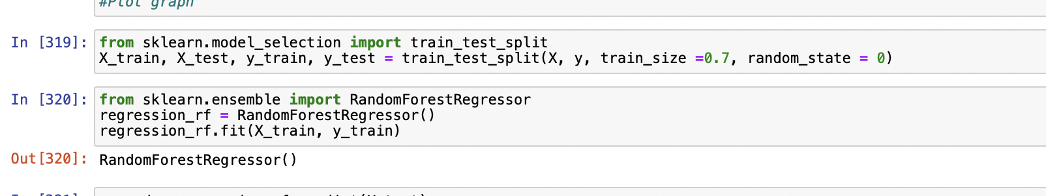

Figure 4.16 . Implementation of random forest: figure illustrates implementation of random forest algorithm where 70% training data is provided to algorithm to get trained Using Sklearn libraries. (image source: “self”)

Implementation of algorithm above(Fig.4.16) is based on dividing training data to 70% & 30% to validation set. I have implemented 40%,50% & 60% for training data but it found that 30% validation is correct size to validation to compare with Outside file of Test data to avoid underfitting & Overfitting. This implementation is possible because of sklearn libraries split function. (Pedregosa et al. 2011)

Hyper Parameter Tunning: considering the feature of Hyperparameter Tunning in random forest as random forest sends the samples randomly to the different decision tree. Please see Figure 4.17 below.

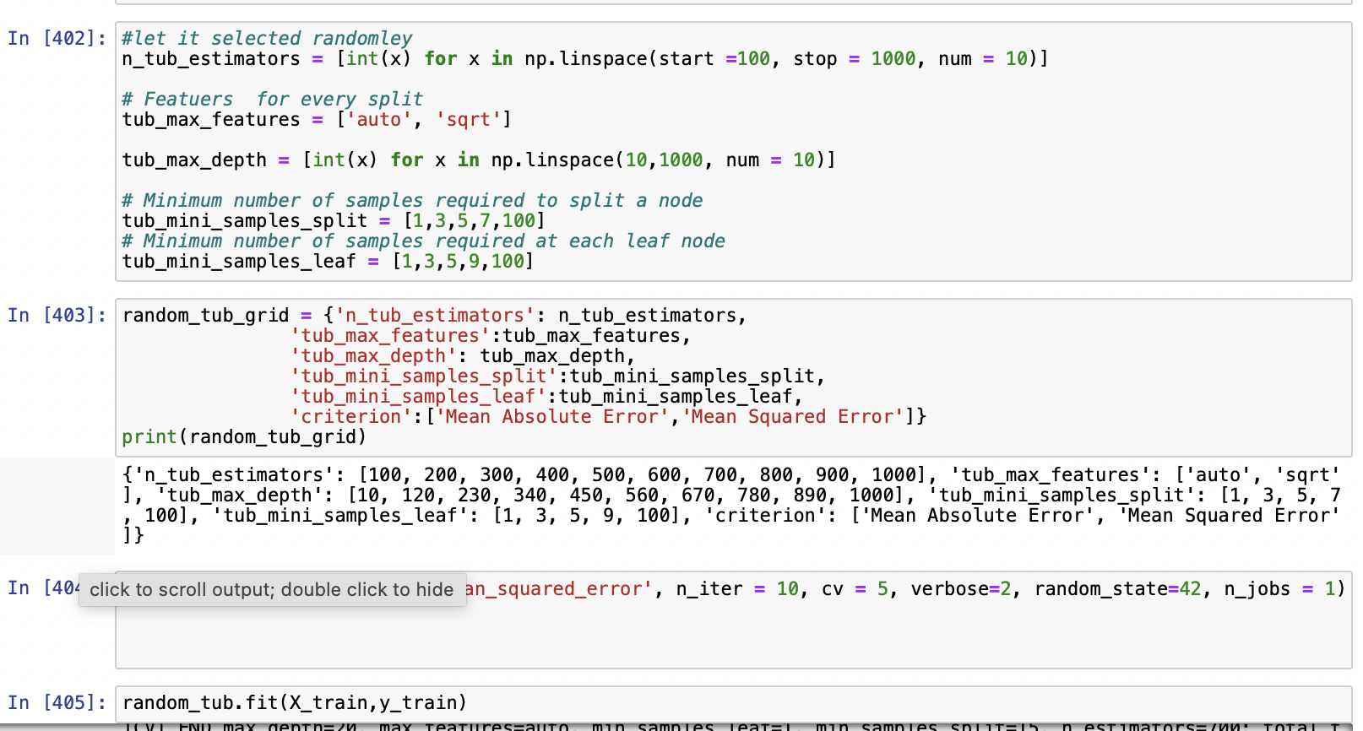

Figure 4.17: Hyper parameter tunning: Figure depicts that tunning of the hyper parameter & the best features getting trained to algorithm

Hyper Parameter Tunning can be done using tunning the important feature as above figure (Fig. 4.17) depicts Important feature _tub_estimator help to tune the number of samples, tub_max_featuers are useful for the selction of featuers , tub_minis_sample _split & tub_mini_samples_leaf. can tune tree & leaf samples.

Please note that it does not have any calculation and it only can be calculated by experiments. (Jordan, 2017)

as per Hyperparameter Tunning (Fig. 4.17). random_tub_grid stores all the Tunned featuers & that can be calculated on cross validation by providing number of iterations & cross validation which will validated against validation set. The parameter shown (Fig 4.17) obtained after many experiments.

**4.6 Implementations of evaluation parameter**:

Please refer Table 4.1 for the filtration of metrics.

|  |  |
| --- | --- |
| **Metrics Name** | **Is that selected? (Yes/No)** |
| Accuracy | No |
| Mean Absolute Error | Yes |
| Mean Squared Error | Yes |
| Huber Loss | Yes |

**Table 4.1.** Metrics evaluation: Table indicates filtration of evaluation parameters for this Research.

Selected evaluation parameter is based on some set of rules. This rule can be described as below. Please refer (Table 4.1)

**Accuracy-** This research cannot take accuracy as a parameter because while predicting cost values. in regression how accurate they are to original value is not important because cost changes with different features.

**Mean Absolute Error** – Yes, This Metrics will Perfect fit for regression method because Mean absolute error will state the difference between the actual point & predicted point. mean absolute error on the predicted value of test data, can be written as below. Please refer formula 4.1 (rownlee, 2022)

$\frac{1}{n}$ $\sum_{i=1}^{n}{Y_{actual}-Y_{estimated}}$ 4.1

Where, $Y_{actual} is$ actual data point

$Y_{estimated}$ is estimated data point

**Mean Squared Error** - This error will help to understand the error trend. This metric squares the error, which is necessary because absolute error of one point is +10 & another point is -10 then mean of that is zero.so mean Squared error can square the difference & show the trend (rownlee, 2022)

) 2 4.2.

**Implementations of evaluation metrics:**

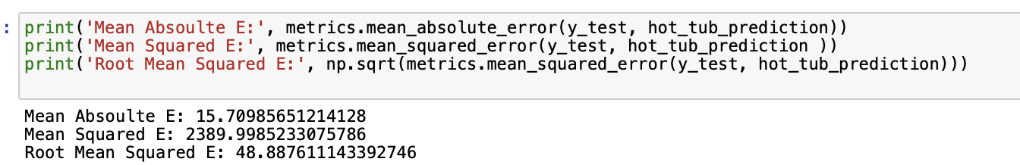

**Figure 4.18** implementation of evaluation metrics: Metrics are implemented from sklearn method of metrics. (rownlee, 2022)  
The implementation of evaluation parameter (Fig 4.18) from metrics method are implemented which calculates the error as per the Equation 4.1 & 4.2.

Huber Loss: As seen above two functions in every data there are outliers whether to consider them or neglect them, will discuss that in next chapter, but this research used the approach to consider the outliers. Mean absolute error ignores the outlier, MSE Consider all the outlier both are extreme condition so Huber loss is a function where user can set value to consider the outliers. Please find the formula of Huber loss in following figure 4.20.

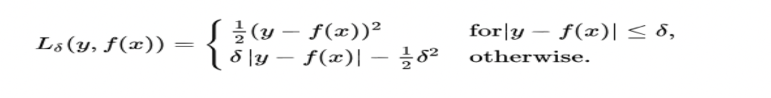**Figure 4.19.** Huber loss : Huber loss formula consist of two formulae depending upon the value of $δ$ (image source:(Seif, 2019))

Where, δ= User defined value (based on consideration for outlier)

f(x)=Function of predicted value

y=actual value.

**Huber Loss Visualization:** It will help to understand the visualization of the Huber loss using value changes in δ**.**

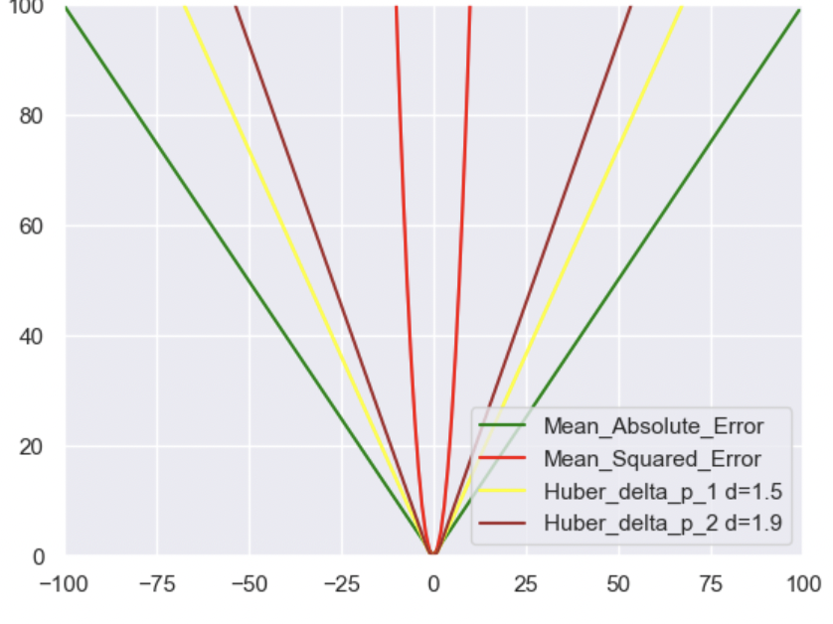 **Figure 4.20**. Huber Loss visualization: This Figure illustrate the use of Huber loss function compared to MAE(Green) & MSE(Red) for the value of δ=1.5(yellow) & δ=1.9(brown) in Huber loss.  
The above graph (Fig. 4.20) depicts the use of Huber loss function where if there are any outliers between MAE(Green) & MSE(Red). This function will plot a data point as per δ and calculate error according to (Fig 4.19) which will result in less loss as it is covering points between MAE & MSE.(image source: “self”)

Please refer python program of Huber loss in appendix 5 section as it is only implementation of formula from Figure 4.19

**4.7 Summary**

This Chapter was a overview of the Crucial things of the research

1. Implementation design

2. data collection: This stage completed with research two main objective

* the objective of automating the laborious data collection method was met.
* Using the scrapper's random function to collect publicly available data in accordance with legal requirements using random function for humane request

3. Exploration and processing of data

4. Feature Engineering

5. Working with different algorithms was also a one of the research objectives that met in this chapter & will evaluate this algorithm in next chapters.

6. Evaluation Parameter.  
will see the result of evaluation parameter in Next chapter.

**Chapter 5**

**Result & Discussion**This is an important chapter in the research; let’s go over the results of the study based on the evaluation parameters seen in the previous chapter and discuss them in the discussion section.

**5.1 Results**

This section will summarise the results of the evaluation parameters. Please keep in mind that this section will only present the facts that are gathered; Discussion about them will be followed in Section 5.2.

**5.1.1 Distribution Plot (dist-plot)**

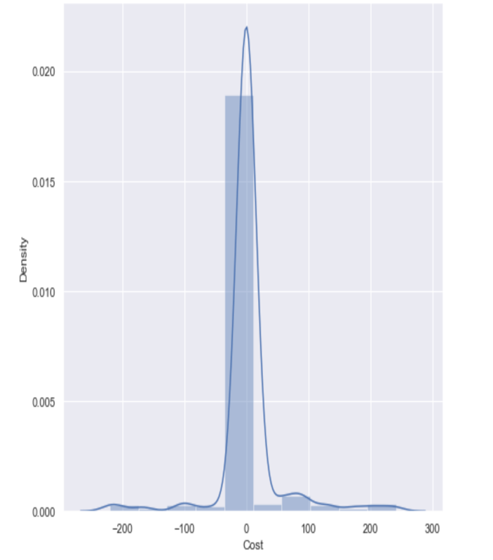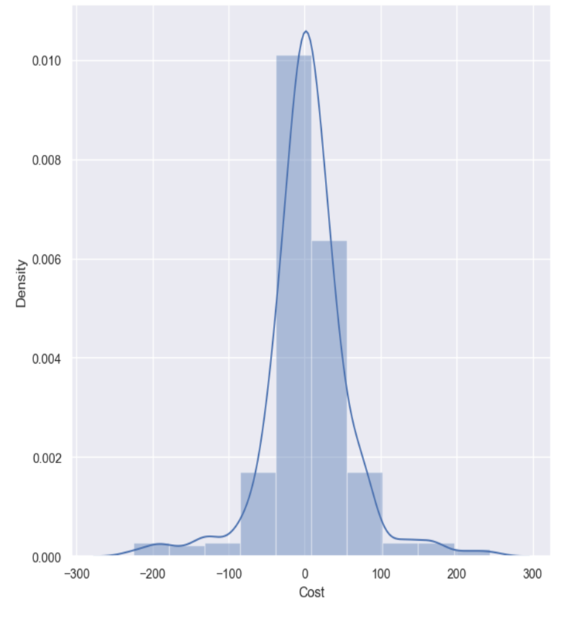

Figure 5.1. Dist-plot decision tree:Dist-plot Figure 5.2. Dist-plot random forest: Decision tree for Number of Dist-plot of random forest for Number of

Histogram(Bins=10) Visible in Blue boxes Histogram(Bins=10) visible in Blue boxes

& Distributed in mean(M=3.91) as & distributed in mean(M=4.1553) as

diffrence between Predicted value & diffrence between Predicted value &

actual value. actual value.

The above Figure depicts the distribution plot of decision tree (Fig.5.1) and random forest (Fig. 5.2) for distance between actual & predicted values. Figure 5.1 Depicts that in the bins of 10 it is distributed in mean (M=3.91) showing more accurate prediction because less Bins(Blue boxes) distributed near zero(Zero is deal prediction) while Figure 5.2 depicts a higher number of bins near zero which is not too accurate prediction in compared to decision tree.

**5.1.2 Scatter Plot**

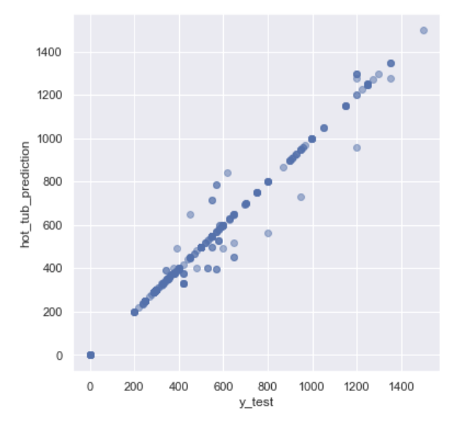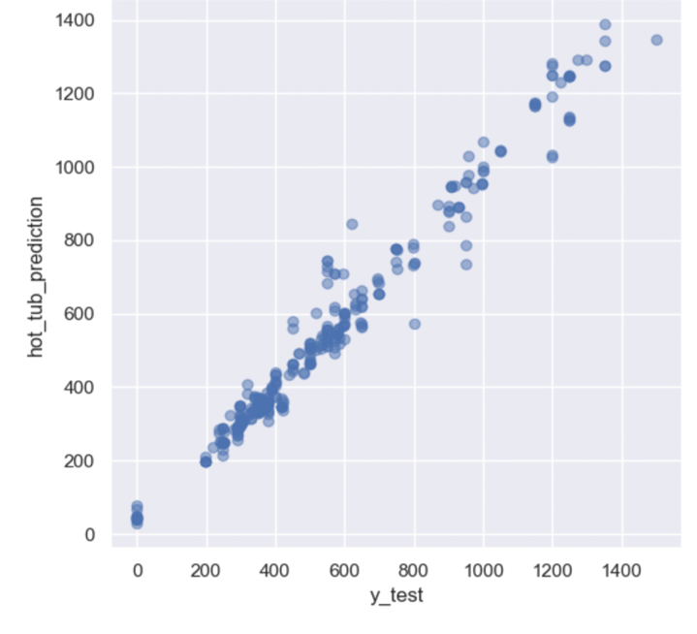

**Figure 5.3.** Scatter plot of decision tree: **Figure 5.4** Scatter plot of random forest:

strong,positive,linear scatter plot for moderate, negative, non-linear scatter mean(M=3.91) for difference between scatterplot for mean(M=4.1553) for

actual & predicted value. diffrence between actual & Predicted

value.

The above Figure depicts the Scatter plot of decision tree (Fig.5.3) and random forest (Fig. 5.4) for distance between actual & predicted values. Figure 5.3 Depicts that in the bins of 10 it is distributed in mean (M=3.91) Showing less scatterness while Figure 5.4 depicts a Higher number of Scatterness.

**Key take away from this result**

* The decision tree performs better on distant plots with less variance and produces more accurate graphs.
* In scatterplot, random forest performs poorly by showing high variance and scatterness.

**5.1.3 Results of Evaluation Parameters.-** Please refer chapter 4 for implementation of evaluation parameter….

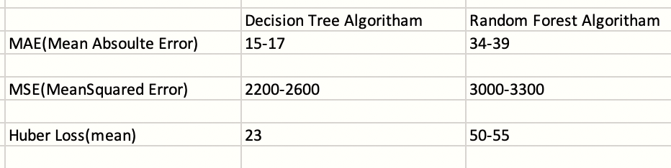

**Figure 5.5**. Overview of the result: A figure is illustrative overview of MAE,MSE &Huber loss for decision Tree & random forest. Decision tree errors showing a very low margin of errors for (M=3.91) .

Above figure depicts the margin of errors which illustartes MAE & Huber loss showing significant diffrence and Decision tree performs better(Fig.5.5).Mean squared error are not showing that significant diffrence for both the algoritham which need to be discussed in discussion section.

Please follow appendix 7 for the result images.

**Key Take away from result**

* In terms of statistical performance, this result can answer research question about algorithms.
* This result shows that the Decision Tree performs better due to a smaller error margin.

**5.1.4 Results of behaviour of model-** It is important to look at the behaviour of the model after getting results of error because stability of the model because stability in model is important factor .

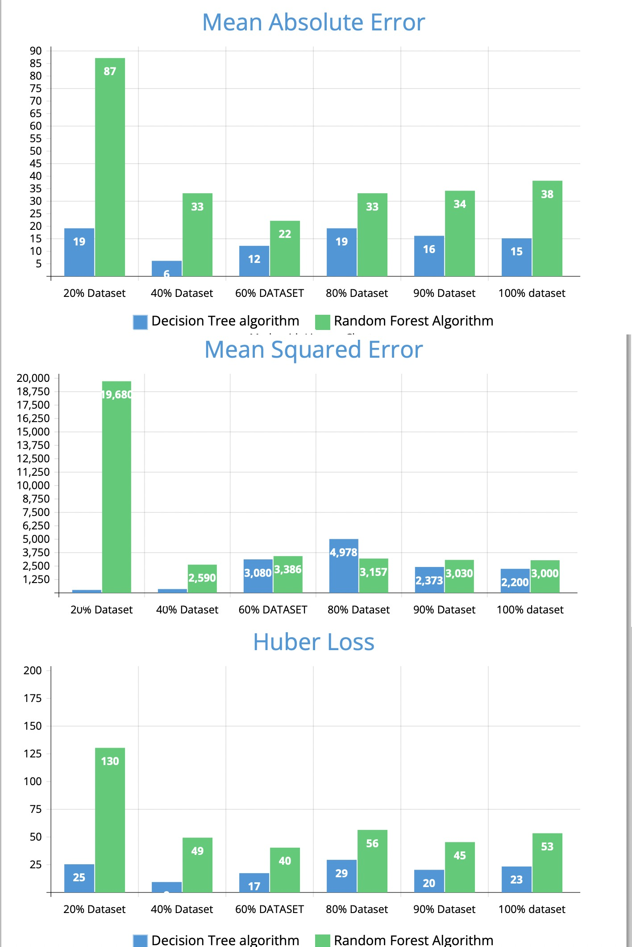

Figure 5.6. Behaviour of model : The figure depicts a behaviour of decision tree(blue) & random forest (green) on certain margin of dataset for all the evaluation parameter showing stability after 80% in all three errors.(algoritham showing Approx. same errors).

This study has divided its dataset in 20,40,60,80,90 percentages to check the behaviour of the model. It can be evaluated that the all the errors Including MAE & Huber loss showing similar trend after 80%.(Fig.5.6). MSE is showing exception trend of 4978 in Mean squared error which is unusual for decision tree that is due to random sample. It can be concluded that Decision tree is showing stability & less error.

**Key facts to take away from result**:

* Data below 80 % is immature data due to instability while after 80% it is stable.
* Decision tree showing least error in all three.

These values are subject to change with data and time, but the results will be roughly the same.

**5.1.5 Result of the heatmap**: As stated in research question ,research will examine various features and their importance in predicting prices. It is critical to understand how different features contribute to and interact with one another. Please Follow Pearson Co-relation heatmap in figure 5.7.Please follow appendix 6 for Pearson matrix.

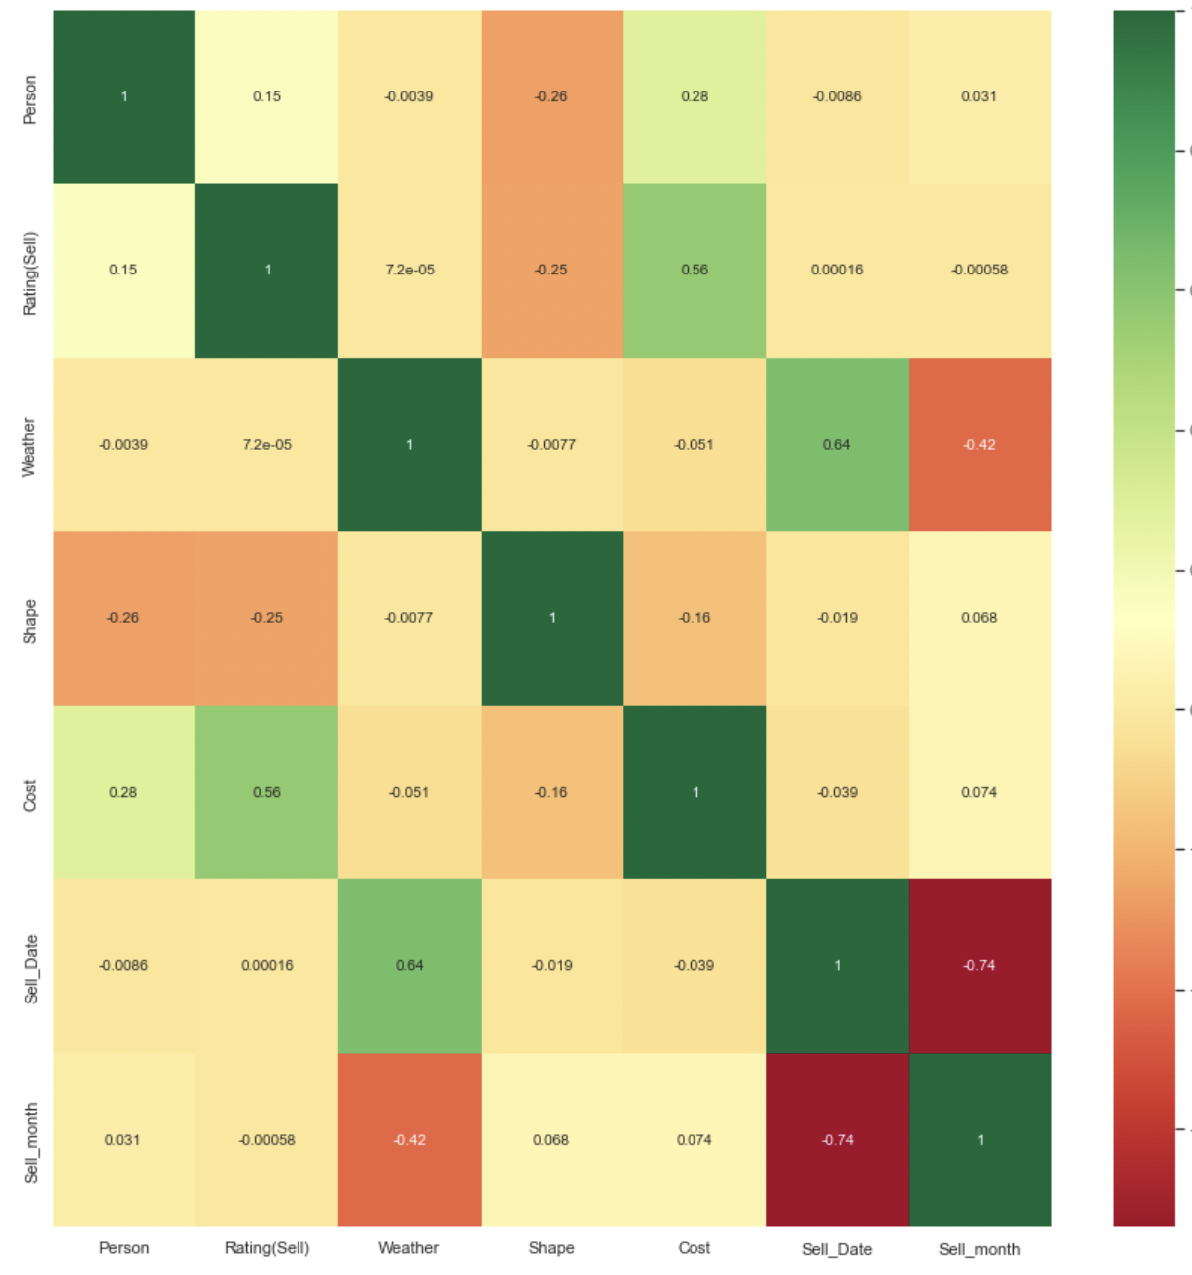

Figure 5.7. Heatmap of features: illustrative heatmap of co-relation of different variables in grid of coloured squared(Red=0 to Green=1) distribution. Illustrating cost is positively co-relating with person & rating.

The above heatmap Depicts a grid of coloured box (Fig. 5.7).showing negative co-relation(Red boxes) & positive co -relation (Green boxes). & moderate co relation( different shade of yellow boxes).

Please see some important observation. Please note in this result section will only see the facts as per the result. will discuss over facts in discussion section

**Key take aways from result:**

**Observation 1**: The cost (dependent feature) increases with month, rating, and person.

**Observation 2**: weather is inversely related to cost.

**Observation 3**: There are many features that are related to each other, but no feature has a correlation greater than 0.90 with more than one feature.  
**Observation 4**: Selling date & Selling month is negatively co-related with each other which is visible in heatmap with Dark Red colour.

**5.2 Discussion**

The findings of this study have provided data insights and have answered a research question of this study that decision tree or random forest which algorithm is providing feature-based predictions for the hot tub & a research question of different co-relation of features to predict the prices. However, due to some limitations, the result should be interpreted with caution. This section discusses the limitations, interpretations, and effects of it in relation to the hypotheses.

Yes, both algorithms can provide and predict prices, but as the research question also states, the accuracy which can be provided more on decision tree algorithm. different categorical features are contributing towards making that decision due to co-relationship between features. To obtain these results, test data is validated against validation data. All of the errors evaluated as performance exhibit the same error trend (Decision Tree errors< Random Forest errors) including important result of Mean absolute Error. Figure 5.5 shows the error analysis in the result section. To confirm this trend, behaviour of the model is analysed the data at 20% and 10% margins, which also confirms the same trend, indicating that it is stable. Please see Section 5.1.4 for the model's behaviour and stability results. to examine various feature and categorical data a heatmap is created which demonstrated co-relation between two variables.

The above research answer gives more room for discussion because the obtained results do not fully align with hypothesis of getting correct and feature-based price prediction by Random Forest algorithm because it was a wrong hypothesis, but predicted prices are in line with past prices and rating was a correct hypothesis, so the hypothesis of whole is partially correct. There are several factors which affects the Hypothesis statement is analysed by this research so it can set the standard for the future work or any achievements found during this research.

The primarily reason of accurate prediction in decision tree is magnitude of the data & difference between the techniques. Please refer chapter 3 for their techniques. Magnitude of the data is very important in this scenario as decision tree choose the next nodes based on the variance reduction & extend the whole tree till the end or minimum error which is giving a one clear direction for algorithms to answer the question. Decision tree provides higher interpretability because user can visualize tree and if there is any bug, they can fix it. Random forest algorithms contain many decisions tree and this all the decision trees receives a random sample, and it aggregates the output. This scenario of random forest creates high errors on dataset. Please find below observation based on result & research.

* Aggregation (ensambling) of different decision trees in random forest algorithms reduces understanding of important variables in dataset. For example, the hot tub's feature named "Tuscany" is not sent as a random sample to some of the trees with higher importance which affects the result.
* The random forest output is the average of all decision trees, which is inaccurate due to the loss of important features and the high mean absolute and squared error.
* Higher cardinality of dataset, as x categorical features are divided in the n number of features after label encoding so random forest cannot generalize the more depth due to non-linearity increases more split in tree.
* The hot tub dataset is clean but has some irregularities because some features may repeat repeatedly, but others are extremely rare which creates illogical tree for random forest.

The reasons stated above are sufficient to analyse the partially incorrect Hypothesis of the research & help to understand the high scatterness in scatterplot(Fig 5.4) for random forest.

Hot tub prices are based on past prices, ratings, and other features is a correct hypothesis because prediction of hot tub prices and the result of the Heatmap is appropriate evidence for this hypothesis as the analysis of the produced heatmap opens up some important discussions. Please refer to section 5.1.5for heatmap observations to continue the discussion on result.(Fig 5.7)

* Heatmap(Fig. 5.7)shows the cost of dependent features increases with month, rating, and person, which is a good thing because in practise, the capacity of person, month, and rating all result in higher costs, so this provides with useful information.
* As can be seen, weather is inversely related. The reason for this is that in label encoding, best weather is labelled as '0' and bad weather for hot tub is labelled as '1', so as the number increases, the value decreases.(Fig 5.7)
* There are many features that are related to each other, but no feature has a correlation greater than 0.90 with more than one feature, so no feature needs to be removed because it won’t provide overfitting..(Fig 5.7)
* ‘cost’ & ’rating’ are co-relating with 0.55 with each other & ‘sell date’ & ’sell month’ negatively co-related with each other which is good trend because as rating increases cost also increases but date and month(showing negative co-relation because scope of data collection shows higher dates in increasing order of year but month are slowly increases(Fig.5.7)

Please keep in mind that negative co-relation are not always bad because they contribute significantly and help to understand the increasing and decreasing features.

All mentioned points above are enough to state the spa prices are fully commensurate with previous spa prices, ratings & features are co-related with each other.

The dataset for this study can be a prime example of theory to establish that in business intelligence problems, decision trees perform better because they can generalise well There are many resources stating the disadvantages of the random forest algorithm(Zhu,2020), but there are very few cases where the disadvantages have been proven. This research also fulfils the gap of literature review 2.3.1 by sending Humane request to website for data collection.

Limitations of collecting data to keep all the features importance is one of the limitations of this study followed by behaviour of the model on practical ground because hot tubs features are changing year by year so updating feature & keep up to date with model is time consuming. However, research on this dataset for current features providing good result & recommendation for future work is provided in section 6.2

**5.3 Summary :**  
This chapter concluded with important points of

1. Demonstration of result.
2. Discussion of result .
3. Answering of research question in discussion 5.2.
4. Evaluated hypotheses in 5.2.
5. Establishment & Limitation.

**Chapter 6**

**Conclusion & Future Work**

**6.1 Conclusion**

The hot tub market is highly volatile & has a dimensional data due to different affected features on hot tub. it is critical to understand the future trends of the hot tub market to predict hot tub prices.

The main question for the research was as follow:

a) Can Decision Tree or Random Forest algorithms provide accurate and feature-based predictions for predicting hot tub prices?

(b) Analysis of different features and categorical data and their importance in predicting price.

This study has tested the Decision Tree and random forest algorithms on the hot tub dataset. Yes, Both algorithms can predict hot tub prices, but decision tree can provide more accurate and less errored prices for future trend. This study also examined the behaviour of various features and established that all features are co-related with each other & negative co-relation is not always bad in analysing future trends for this dataset.

However, result for the incorrect hypothesis also analysed by working on implementation design. The data for this study was collected using an automated data collection tool by sending humane request to achieve the objective of this study. and transferred to a raw excel file, where it was processed using excel and cleaned before being fed into machine learning algorithms. This algorithm produced some surprising results that differed from the hypotheses because the random forest algorithm was not appropriate for the hot tub dataset due to unbalanced data, dimensionality, and the loss of an important feature, which resulted in a scattered scatterplot. It can be argued that the model is unstable, but to test this assumption, model stability test has been conducted  which showd that the model becomes stable after 75-80% of data.

This research can be concluded that the Random Forest Algorithm does not always make good decisions. The magnitude, dimensionality, and other aspects of data are also very important in predicting the price, which is a rare finding in other studies. Result of this research has achieved its important objective of to make new marketing policies, offer as a business intelligent perspective. Although processing and cleaning of collected data can result in the loss of important features for training the model, and it is beyond the scope of this study to collect more data and analyse each aspect of data, further research on different behaviour of this model and the establishment of simple techniques to process the data without losing features is necessary due to the limitations of this study

**6.2 Future Work**In the future, Aimed to simplify the task of data processing after data collection as the limitation of this study because, in order to continue predicting hot tub prices, it is critical to not miss any important feature and to analyse both algorithms for the huge data set and to record the behaviour of the dataset on the more dimensional dataset

More aspects of implementation design should be included in future work. Yes, this study established a more humane data collection process, but the hot tub dataset can contain  complex dimensionalities, so it is suggested that in future work,  When collecting data from various websites, the scrapper should define cleaning & important features parameter to scrape the data. If the data is not in the scrapper's set parameter list, then and only then it should be cleaned by humane. This procedure will eliminate 80% of the work required to feed data to the algorithm. Even though a complexity and fear of losing important features must be derived from a different strategy and subject to future work.

There will always be discussion on the data and behaviour of the model because change in data sizes can change the behaviour of the model but in the business intelligent problem definition such as this further work on the limitation on acceptability of evaluation parameter of the model should be done because according to George box "All models are wrong, but some are useful" (Box, 2022) .Choosing a model can provide an accurate result, but how strong and practically perfect it is? This must be derived and subjected to further work.

**Chapter 7**

**Evaluation**

**7.1 Self evaluation**

There are some points where I evaluated the research

* Yes, this research is answering the question mentioned, even though my hypothesis is partially correct because it is the time when I evaluated myself about the reasons for my hypothesis and different factors, and it gave me a chance to research more about the subject and algorithms to check about my partially correct hypotheses. This is where I learned many things practically, which is very difficult to grasp as a single topic.
* I am proud of analysing a Prices as business prospective & established idea of generalisation by decision tree.
* This self-evaluation also includes some learning about how to analyse a situation and problem, as well as how to respond to those problems differently. This is where I need to focus my efforts in the future.
* I mentioned SQL and Tableau Software to use, but I evaluate that I used it in the objective of my project but was unable to explore it in depth which i can learn.

**7.2 Key learnings** : There are things which I learned during the process of research.

* Time management Skills (Managing other activity balance while writing the project report)
* I have tried to learn formatting skills .
* Different perspective to analyse the problem & finding solutions
* Technical skills like Tableu,Python, Machine learning tools .
* Improving mindset as data analyst
* Analysis skills of research papers.

**7.3 Project Management**

Please refer appendix 1 for the project plan.

Managing any project is critical, but I tried to divide the tasks and set small goals for each day and week to help me analyse completed work and inspiration for other work. The project plan includes data collection, data processing, working on algorithms, and report generation.

Data cleaning took it long way to complete on time as per project planning. I have targeted to finish data collection before mid-august 2022 but data cleaning took longer than expected.

Another machine learning task encountered with evaluation parameters that took much longer than expected.

Please refer Appendix 1 for more detail.­

**Chapter 8**

**Bibliography**

*Academic Integrity and Academic Misconduct*. [online] Available at: <https://www.herts.ac.uk/__data/assets/pdf_file/0007/237625/AS14-Apx3-Academic-Misconduct.pdf> [Accessed 15 July 2022].

Bansal, S., n.d. *10 Super Neat Ways to Clean Data in Excel Spreadsheets*. [online] Trump Excel. Available at: <https://trumpexcel.com/clean-data-in-excel/> [Accessed 9 September 2022].

Box, G., 2022. *“All models are wrong, but some are useful”. George E. P. Box – AdMoRe ITN*. [online] Lacan.upc.edu. Available at: <https://www.lacan.upc.edu/admoreWeb/2018/05/all-models-are-wrong-but-some-are-useful-george-e-p-box/> [Accessed 22 September 2022].

Chelliah, I., 2021. *Line of Best Fit in Linear Regression*. [online] Medium. Available at: <https://towardsdatascience.com/line-of-best-fit-in-linear-regression-13658266fbc8> [Accessed 20 September 2022].

Dib, F., n.d. *regex101: build, test, and debug regex*. [online] regex101. Available at: <https://regex101.com> [Accessed 21 September 2022].

Dr Olga, A. (2021). MSc Project Handbook .Internal Project Handbook.

Unpublished.

Geek, G., 2022. *Python Programming Language - GeeksforGeeks*. [online] GeeksforGeeks. Available at: <https://www.geeksforgeeks.org/python-programming-language/> [Accessed 9 September 2022].

Geek, S., 2022. *SQL Tutorial - GeeksforGeeks*. [online] GeeksforGeeks. Available at: <https://www.geeksforgeeks.org/sql-tutorial/> [Accessed 12 September 2022].

GOV.UK. 2018. *Data protection*. [online] Available at: <https://www.gov.uk/data-protection> [Accessed 27 August 2022].

Henrys, K., 2021. *Importance of Web Scraping in E-Commerce and E-Marketing*. [online] Available at: <https://papers.ssrn.com/sol3/papers.cfm?abstract_id=3769593> [Accessed 25 August 2022].

Hot Tub Market Size, R., n.d. *Hot Tub Market Size, Share, Industry Forecast 2029*. [online] Fortunebusinessinsights.com. Available at: <https://www.fortunebusinessinsights.com/hot-tub-market-104629> [Accessed 16 September 2022].

Jupyter.org. 2022. *Project Jupyter*. [online] Available at: <https://jupyter.org/> [Accessed 9

September 2022].

Jordan, J., 2017. *Hyperparameter tuning for machine learning models.*. [online] Available at: <https://www.jeremyjordan.me/hyperparameter-tuning/> [Accessed 20 September 2022].

Kiefer, C.,no date. *Assessing the Quality of Unstructured Data: An Initial Overview*. [online] Ceur-ws.org. Available at: <http://ceur-ws.org/Vol-1670/paper-25.pdf> [Accessed 11 July 2022].

Liu, B., Ma, M. and Chang, J. eds., 2012. *Information Computing and Applications: Third International Conference, ICICA 2012, Chengde, China, September 14-16, 2012, Revised Selected Papers* (Vol. 7473). Springer.

Maida, J., 2022. *$ 1.3 Bn growth opportunity in Hot Tub Market 2021-2025 | Technavio estimates 8.8% YOY growth in 2021*. [online] Prnewswire.com. Available at:<https://www.prnewswire.com/news-releases/-1-3-bn-growth-opportunity-in-hot-tub-market-2021-2025--technavio-estimates-8-8-yoy-growth-in-2021--301384840.html> [Accessed 24 August 2022].

Maulud, D. and Abdulazeez, A.M., 2020. A review on linear regression comprehensive in machine learning. *Journal of Applied Science and Technology Trends*, *1*(4), pp.140-147.

file:///Users/kunaldeshpande/Downloads/57-Full%20Manuscript-303-1-10-20210101%20(1).pdf

Matplotlib.org. 2022. *Matplotlib — Visualization with Python*. [online] Available at: <https://matplotlib.org/> [Accessed 19 September 2022].

Numpy.org. 2022. *NumPy*. [online] Available at: <https://numpy.org/> [Accessed 9 September 2022].

Pedregosa, F., Varoquaux, G., Gramfort, A., Michel, V., Thirion, B., Grisel, O., Blondel, M., Prettenhofer, P., Weiss, R., Dubourg, V. and Vanderplas, J., 2011. Scikit-learn: Machine learning in Python. *the Journal of machine Learning research*, *12*, pp.2825-2830.

Python, R., n.d. *Beautiful Soup: Build a Web Scraper With Python – Real Python*. [online] Realpython.com. Available at: <https://realpython.com/beautiful-soup-web-scraper-python/> [Accessed 9 September 2022].

Raj, P., 2022. *10 Health Benefits of Using a Hot Tub on World Sleep Day - MSpa UK*. [online] MSpa UK. Available at: <https://www.mspauk.co.uk/blog/10-health-benefits-of-using-a-hot-tub-on-world-sleep-day/> [Accessed 18 September 2022].

rownlee, J., 2022. *Regression Metrics for Machine Learning*. [online] Available at: <https://machinelearningmastery.com/regression-metrics-for-machine-learning/> [Accessed 15 September 2022].

Selig, J., 2022. *What Is Machine Learning? A Definition.* [online] Expert.ai. Available at: <https://www.expert.ai/blog/machine-learning-definition/> [Accessed 29 August 2022].

Selenium. 2022. *WebDriver*. [online] Available at: <https://www.selenium.dev/documentation/webdriver/> [Accessed 23 September 2022].

Sharma, A., 2020. *Decision Tree Split Methods | Decision Tree Machine Learning*. [online] Analytics Vidhya. Available at: <https://www.analyticsvidhya.com/blog/2020/06/4-ways-split-decision-tree/#:~:text=Decision%20Tree%20Splitting%20Method%20%231,is%20split%20into%20child%20nodes.> [Accessed 1 September 2022].

T, S., 2019. *Entropy: How Decision Trees Make Decisions*. [online] Medium. Available at: <https://towardsdatascience.com/entropy-how-decision-trees-make-decisions-2946b9c18c8> [Accessed 18 September 2022].

Upadhyay, S., Pant, V. and Bhasin, S., 2017. *Articulating the construction of a web scraper for massive data extraction*. [online] Ieeexplore.ieee.org. Available at: <https://ieeexplore.ieee.org/abstract/document/8117827> [Accessed 9 July 2022].

Seif, G., 2019. *Understanding the 3 most common loss functions for Machine Learning Regression*. [online] Medium. Available at: <https://towardsdatascience.com/understanding-the-3-most-common-loss-functions-for-machine-learning-regression-23e0ef3e14d3> [Accessed 16 September 2022].

W3schools.com. 2022. *Pandas Introduction*. [online] Available at: <https://www.w3schools.com/python/pandas/pandas_intro.asp> [Accessed 9 September 2022].

Zhong, Y., 2016. *The analysis of cases based on decision tree*. [online] Ieeexplore.ieee.org. Available at: <https://ieeexplore.ieee.org/document/7883035/references#references> [Accessed 19 August 2016].

Zhu, T., 2020, August. Analysis on the Applicability of the Random Forest. In *Journal of Physics: Conference Series*(Vol. 1607, No. 1, p. 012123). IOP Publishing.

**Chapter 9**

**Appendices**

**Appendix 1: Project plan/ Project management/**

Please find the Project plan as a Gantt chart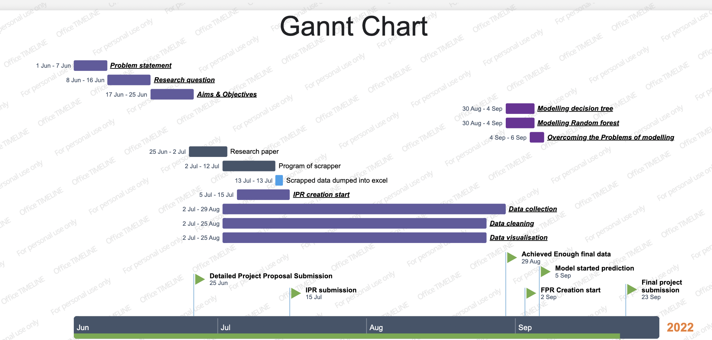 **Figure 9.1**: Image depicts the Gantt chart of Project plan from 01/06/2022 to 23/09/2022.Images with green flag are milestones of project.(Image source: “self")

Gannt Chart is built on (Build native PowerPoint timelines online - Office Timeline Online)  
Please find the overview of Gannt chart presentation in Table below (Appendix Table 1.1)

|  |  |  |  |
| --- | --- | --- | --- |
| **Start Date** | **End date** | **Achievement** | **Inclusive main**  **Task** |
| 01-06-2022 | 25-06-2022 | Detailed Project Proposal | Problem statement, Aim & Objectives, Research question |
| 26-06-2022 | 15-07-2022 | Interim Project Report | Scrapper Program  Data collection-1 |
| 15-07-2022 | 29-08-2022 | Achieving  Final Data | Data collection,visualisation,Cleaning,research paper review |
| 29/08/2022 | 05-09-2022 | Modelling Algorithm | Decision Tree & Random forest Modelling |
| 05-09-2022 | 05-09-2022 | Model start predicting | Model started prediction |
| 02-09-2022 | 23-09-2022 | FPR | FPR terminology & creation |

**Appendix Table 1.1** : Key achievements of Gannt chart: Table depicts important task As achievement & Showing inclusive main task.

**Key notes to take away from Gannt chart**

* Due to the complexity of the data, data cleaning and collection it took longer than expected.
* In modelling decision tree it encountered with outliers, so consideration of outliers took a little longer than expected.

**Appendix 2 : Destined Website for URL**

Please find the names of the competitors who sell the identical products whose URL for the hot tub has been used as a source link in excel file. Please note that this is just a example source URL.[Last Accessed: 4 sept 2022]

* Amazon:(<https://www.amazon.co.uk/s?k=mspa&crid=3102XRVI4YJ9Q&sprefix=mspa%2Caps%2C51&ref=nb_sb_noss_1>).
* Alice Garden: (<https://www.alicesgarden.co.uk/product/spa-205cm-6-person-inflatable-camaro-6-mspa-leatherette-black-with-accessories>).
* Cambs Hot tub: (<https://www.cambshottubs.co.uk/?s=mspa>).
* Garden store Direct: ([https://www.gardenstoredirect.com/index.php?route=product/search&search=mspa](https://www.cambshottubs.co.uk/?s=mspa)).
* Mspa Uk: ([https://www.mspauk.co.uk](https://www.mspauk.co.uk/)).
* Frono: (<https://frono.uk/mspa-6-person-square-hot-tub-spa.html>).

**Appendix 3: Regex Explanation**

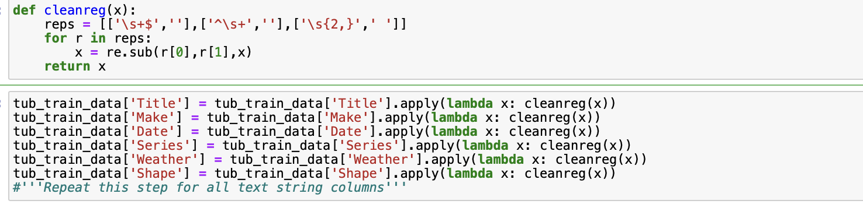

**Figure 9.2:** Use of regex to clean the data: This regex function to clean data in jupyter notebook.

The above figure depicts the use of regular expression in cleaning the data in jupyter notebook.

Let’s understand this regex of image as visible the function Cleanreg(x)

representing reps variable with \s equals no whitespace, $ end of string , ‘ ‘ is a blank string. Adding three combinations based on our data to remove the white space.

Passing that cleanreg(x) function to every column to clear the extra whitespaces using lambada representing ‘match” so reps combination checked by lambda by finding that match & removing that using regex function.

**Appendix 4: Categorical Variable into Numerical**

Please find the following table which will depict that what we have done to different variable to con vert into numerical.

|  |  |
| --- | --- |
| **Variables** | **Technique to convert them in numerical** |
| Make | One Hot encoding |
| Date (e.g., 20/04/2022) | three different columns for date, month & year |
| Series | One Hot encoding |
| Title | One Hot encoding |
| Person | Already numerical value |
| Rating | Already Numerical value |
| weather | Label encoding |
| Shape | Label encoding |

**Appendix Table 1.2:** Categorical Variable into Numerical

Above table depicts how this research converted categorical data into numerical.

**Appendix 5: Implementation of Hubber Loss**

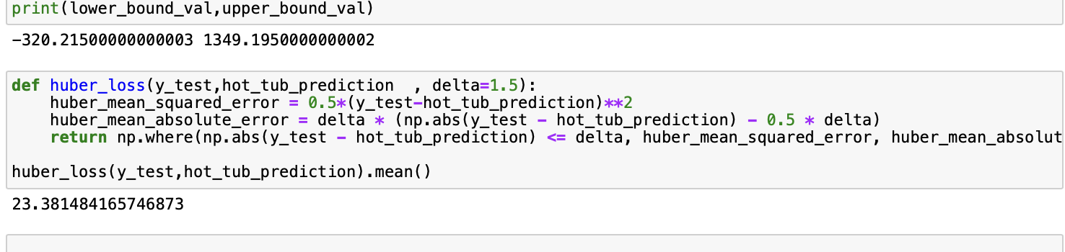

**Figure 9.3**.Implementation of Huber loss: figure depicting Python code for huber loss function.

Please find implementation of Huber loss & calculating loss of validation set & prediction dataset As per discussion in section 4.6 of chapter 4.This implementation is the same translation of formula mentioned in Figure 4.19

**Appendix 6: Pearson co-relation matrix**

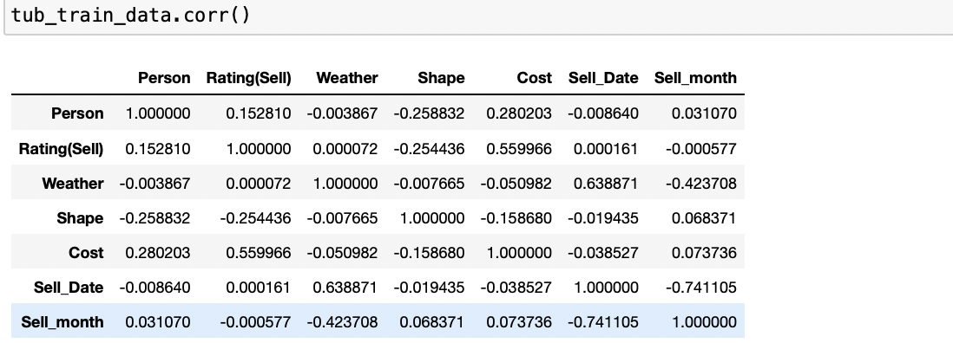**Figure 9.4**:Pearson co-relation matrix : depicting relationship between dependent Independent variables

(Please refer section 5.1.5 for explanation of this metrics)

**Appendix 7 : Result of evaluation parameter in images**



Figure 9.5: Evaluation parameter result of Decision Tree

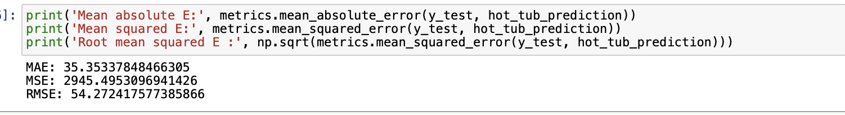

Figure 9.6: Evaluation parameter result of Random forest algorithm

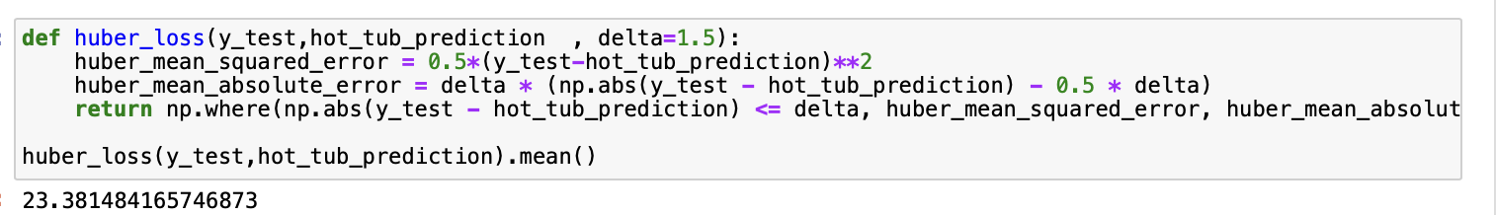**Figure 9.7** : Huber loss result of Decision Tree

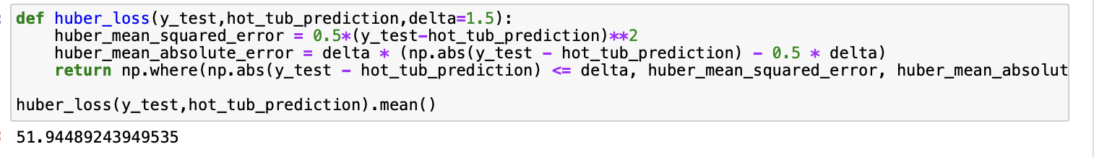

Figure 9.8 : Huber loss result of Random forest algorithm

**Appendix 8 : Project Code**  
**Example Project code of Scrapper  
#Importing Libraries**

import csv

from bs4 import BeautifulSoup

import pandas as pd

import numpy as np

import requests

import time

import csv

import datetime

from selenium import webdriver

import datetime

import random

import os

import re

***# Configurations of web driver***

pd.set_option('display.max_rows', None)

pd.set_option('display.max_columns', None)

driver = webdriver.Chrome( r'/Users/kunaldeshpande/Documents/chromedriver 2')

column_header = ['Title', 'Price', 'Date', 'URL']

price_regex = r"[0-9]+\.?[0-9]*"

**#ReadingURLfrom localcomputer**

def readB2BSiteLinks(webSiteType):

webSiteLink = ""

switch = {"MSpa":r"/Users/kunaldeshpande/Desktop/project/Scrap/mspa/mspalinks.csv” }

df = pd.read_csv(switch[webSiteType])

return df

**#GettingHTMLData of targeted link**

def scrapB2BSite(siteLinks):

page = requests.get(siteLinks)

soup = BeautifulSoup(page.content, "html.parser")

_formatted_Soup = BeautifulSoup(soup.prettify(), "html.parser")

**try:**

title = _formatted_Soup. Find('h1' , 'title-heading-left fusion-responsive- typography-calculated').get_text().strip()

price= _formatted_Soup. Find('bdi').text

price= "".join(price)

price = price.strip()

today = datetime.datetime.now().isoformat()

data = [title, price, today, siteLinks]

return data

except AttributeError as e:

print(e)

except Exception as e:

print(e)

return []

***#Activating Scrapper***

***#PuttingRandom variable***

for site_links in b2b_site_links['Link']:

data = scrapB2BSite(site_links)

print(data)

sleepTimeInSeconds = random.randrange(2,10)

Sleep_mspa=time.sleep(sleepTimeInSeconds)

Sleep_mspa

**#Dumping data in excel**

if(len(data)>0):

writeB2BSiteDataToCsvFile('/Users/kunaldeshpande/Desktop/Final Data/messy_Data_dates/sep4.csv', data, column_header)

**Example of output**

['MSpa Bergen Comfort Series C-BE061', '629.99', '2022-09-14T09:48:09.759771', 'https://www.mspauk.co.uk/products/mspa-bergen-comfort-series-c-be061/']

**Note**: All the scrapping file are same as above just excel files will be change for reading URL and dumping data & targeted HTML are different for different websites.

-----------------------------------------------------------------------------------------------------------------------

**Project Code of algorithms**

**#Importing Libraries**

import numpy as np

import pandas as pd

import matplotlib.pyplot as plt

import seaborn as sns

import re # importing regression

**#importing data set**

tub_train_data=pd.read_csv("/Users/kunaldeshpande/Desktop/Final Data/Experiments/19055288/19055288_training data.csv”)

tub_train_data

tub_train_data.dropna()

tub_train_data["Shape"].value_counts()

tub_train_data.info()

tub_train_data

tub_name=tub_train_data['Title']

tub_cost=tub_train_data['Cost']

**#Cleaning Of Jupyter notebook**

def cleanreg(x):

reps = [['\s+$',''],['^\s+',''],['\s{2,}',' ']]

for r in reps:

x = re.sub(r[0],r[1],x)

return x

tub_train_data['Title'] = tub_train_data['Title'].apply(lambda x: cleanreg(x))

tub_train_data.shape

tub_train_data.isnull().sum()

----------------------------------------------------------------------------------------------------------------

**#Dividing Date into day and month**

**#This code’ s logic is derived from (Write a program in Python to split the date column into day, month, year in multiple columns of a given dataframe, 2022)**

**#https://towardsdatascience.com/hyperparameter-tuning-in-python-21a76794a1f7**

tub_train_data["Sell-Date"] = pd. to_datetime (tub_train_data.Date, format="%d/%m/%Y").dt.day

tub_train_data["Sell-month"] = pd.to_datetime(tub_train_data["Date"], format = "%d/%m/%Y").dt.month

tub_train_data.drop (["Date"], axis = 1, inplace = True

tub_train_data.head(15)

----------------------------------------------------------------------------------------------------------------

**# I do have to handel categorical data which is generally nominal & ordinal data,**

**#nomianal dont have any data in order so it use label encoder**

**#ordinal data is in the order so I can use label encoder**

tub_train_data["Make"].value_counts()

**#this graph shows the Mspa sells highest in mspa**

sns.catplot(y = "Cost", x = "Make", data = tub_train_data.sort_values ,kind="boxen", height = 8, aspect = 3)

plt.sho

**# Graph hot tub tite vs Cost**

sns.catplot (y = "Cost", x = "Title", data = tub_train_data. sort_values("Cost", ascending = False), kind="boxen", height = 34, aspect = 8)

plt.show()

**#OneHotEncoding**

Make = tub_train_data[["Make"]]

Make = pd.get_dummies(Make, drop_first= False)

Make.head(50)

**#encoding**

Title = tub_train_data[["Title"]]

Title = pd.get_dummies(Title, drop_first= True)

tub_train_data["Series"].value_counts()

**# Series comes under nominal data so i will do encoding**

Series = tub_train_data[["Series"]]

Series = pd.get_dummies(Series, drop_first= False)

**#Graph Series vs Cost**

sns.catplot(y = "Cost", x = "Series", data = tub_train_data.sort_values("Cost", ascending = False), kind="boxen", height = 30, aspect = 5)

plt.show()

**#weather & shape are cateogarical data**

tub_train_data.replace({"Sunny": 0, "Cloudy": 1, "Dry": 2, "Round":3, "Square":5, "Square Round":6, "Square round":7}, inplace = True)

#**combining tub_train_data + Make of hot tub + Title of hot tub+ Series of hot tub**

tub_data_train = pd.concat([tub_train_data, Make, Title, Series], axis = 1)

tub_data_train.head()

tub_data_train.drop(["Make", "Title", "Series"], axis = 1, inplace = True)

**##TEST DATA**

**##(different Excel File)**

tub_test_data=pd.read_csv("/Users/kunaldeshpande/Desktop/Final Data/Experiments/19055288/19055288_testdata.csv)

tub_test_data.info()

tub_test_data["Title"].value_counts()

tub_test_data.shape

tub_test_data.head()

tub_test_data.shape

tub_test_data.head(100)

tub_test_data.dropna(inplace=False)

**(Repeating all the process of training data)**

tub_test_data["Sell-Date"] = pd.to_datetime(tub_test_data.Date, format="%d/%m/%Y").dt.day

tub_test_data["Sell-month"] = pd.to_datetime(tub_test_data["Date"], format = "%d/%m/%Y").dt.month

tub_test_data.drop(["Date"], axis = 1, inplace = True)

tub_test_data.head(15)

tub_test_data["Make"].value_counts()

**# As is Nominal Categorical data i will perform OneHotEncoding**

Make =tub_test_data[["Make"]]

Make = pd.get_dummies(Make, drop_first= False)

tub_test_data["Title"].value_counts()

**# Title is under nominal data so i have to perform one hot encoding**

Title = tub_test_data[["Title"]]

Title = pd.get_dummies(Title, drop_first= False)

tub_test_data["Title"].value_counts()

tub_test_data["Series"].value_counts()

**#one hot encoding dividing columns into more columns**

Series =tub_test_data[["Series"]]

Series = pd.get_dummies(Series, drop_first= False

**#label encoding**

tub_test_data.replace({"Sunny": 0, "Cloudy": 1, "Dry": 2, "Round":3, "Square":5, "Square Round":6, "Square round":7}, inplace = True)

tub_test_data.head()

**#lets merge all encoding**

tub_data_test = pd.concat([tub_test_data, Make, Title, Series], axis = 1)

tub_data_test

tub_data_test.drop(["Make", "Title", "Series"], axis = 1, inplace = True)

tub_data_test.head()

tub_data_test.shape

tub_data_test.columns

tub_data_test.shape

**#This algoritham provides the best featuer selection techniques.**

**#finding best featuer which can contribute towards dependent featuer cost by heatmap,feature_importance,SelectKBest**

tub_data_train.shape

tub_data_train.columns

**#Assigning all variable Feature to X**

X = tub_data_train.loc[:,['Person', 'Rating(Sell)', 'Weather', 'Shape', 'Sell_month',

'Make_Alice', 'Make_Amazon', 'Make_Cambs', 'Make_Frono', 'Make_GSD',

'Make_Mspa', 'Title_Bergen Four Person', 'Title_Bergen Six Person',

'Title_Camaro Four Person', 'Title_Camaro Six Person',

'Title_Carlton Six person', 'Title_Exotic Four Person',

'Title_Exotic Six Person', 'Title_Lite Four Person',

'Title_Lite six person', 'Title_Mono Six Person',

'Title_Nest Two Person', 'Title_Otium Six Person',

'Title_Ottomon Four Person', 'Title_Ottomon Six person',

'Title_Rimba Six person', 'Title_Silver Cloud Four person',

'Title_Silver Cloud Six Person', 'Title_Soho Six Person',

'Title_Starry Six Person', 'Title_Tekapo Four person',

'Title_Tekapo Six person', 'Title_Tuscany Six Person',

'Title_Vito Six Person', 'Series_Comfort', 'Series_Delight',

'Series_Frame', 'Series_Lite', 'Series_Muse', 'Series_Premium',

'Series_Urban'],]

X.head()

X.shape

**#Assigning dependent variable in y**

y = tub_data_train.iloc[:, 4]

y.head()

**# Finding correlation between features**

plt.figure(figsize = (21,21))

sns.heatmap(tub_train_data.corr(), cmap = "gnrd")

plt.show()

**#Producing Heatmap**

plt.figure(figsize=(24,20))

hot_tub_relation = tub_train_data.corr()

sns.heatmap(hot_tub_relation, annot=True, cmap=plt.cm.CMRmap_r)

plt.show()

plt.figure(figsize=(14,10))

hot_tub_relation = tub_data_train.corr()

sns.heatmap(hot_tub_relation, annot=True, cmap=plt.cm.CMRmap_r)

plt.show()

**#printing co-relation**

tub_train_data.corr()

**#Featureselection**

from sklearn.ensemble import ExtraTreesRegressor

feature_select = ExtraTreesRegressor()

feature_select.fit(X, y)

print(feature_select.feature_importances_)

feature_select.feature_importances_.shape)

sns.heatmap(feature_select.feature_importances_.reshape(41,1))

**#feat_importance of importance**

Plt.figure()

importances = pd.Series(feature_select.feature_importances_, index=X.columns)

importances.nlargest(40).plot(kind='barh')

plt.show()

**#plotting graph**

**#Divivng data in train section & test section**

from sklearn.model_selection import train_test_split

X_train, X_test, y_train, y_test = train_test_split(X, y, train_size =0.7, random_state = 0)

**#Importing Decision Tree Algoritham**

from sklearn import tree

**#model of tub_model**

from sklearn.tree import DecisionTreeRegressor

tub_model= tree.DecisionTreeRegressor()

tub_model.fit(X_train,y_train)

y_tub_pred =tub_model.predict(X_test)

tub_model.score(X_train, y_train)

x=tub_model.score(X_test, y_test)

print("Accuarcy of the training model for the predicting output is ")

print(x)

sns.distplot(y_test-y_tub_pred)

plt.show()

plt.scatter(y_test, y_tub_pred, alpha = 0.3)

plt.xlabel("y_test")

plt.ylabel("y_tub_pred")

plt.show()

**#Importing Random Forest Algoritham**

(Please note that this program is implemented in another file)

from sklearn.ensemble import RandomForestRegressor

tub_model= RandomForestRegressor()

tub_model.fit(X_train, y_train)

----------------------------------------------------------------------------------------------------------------

**#Hyperparameter Tuning**

**#Hyper parameter logic is derived from the article (Hyperparameter tuning in Python, 2022)**

**# https://towardsdatascience.com/hyperparameter-tuning-in-python-21a76794a1f7**

from sklearn.model_selection import RandomizedSearchCV

n_tub_estimators = [int(x) for x in np.linspace(start = 100, stop = 1000, num = 10)]

tub_max_features = ['auto', 'sqrt']

tub_max_depth = [int(x) for x in np.linspace(5, 30, num = 6)]

tub_min_samples_split = [1,3,5,7,100]

tub_min_samples_leaf = [1, 3, 5, 9,100]

random_tub_grid = {'tn_tub_estimators': n_estimators,

'tub_max_features': max_features,

'tub_max_depth': max_depth,

'tub_min_samples_split': min_samples_split,

'tub_min_samples_leaf': min_samples_leaf}

rf_random= RandomizedSearchCV(estimator =rf_random, param_distributions = random_grid,scoring='neg_mean_squared_error', n_iter = 12, cv = 7,verbose=2,n_jobs=2)

------------------------------------------------------------------------------------------------------------------------  
 **Note: Please follow same processs as below for both algorithams**

#**Checking Errors**

**from sklearn import metrics**

print(“Mean Absolute E”:', metrics.mean_absolute_error(y_test, y_tub_pred))

print(“Mean Squared E” metrics.mean_squared_error(y_test, y_tub_pred))

**#VISUALIZATION OF DECISION TREE**

from sklearn import tree

import graphviz

tree_data_visual = tree.export_graphviz(tub_model)

graphviz.Source(tree_data_visual)

hot_tub_prediction = tub_model.predict(X_test)

**#REUSING FILE**

import pickle

file = open('tub_tree.pkl', 'wb')

pickle.dump(tub_model, file)

forest = pickle.load(model)

tub_data_test.columns

tub_data_test.shape

tub_data_test

**#IMPORTING FINAL TEST FILE & DUMP IT IN EXCEL**

hot_tub_predcition = forest.predict(tub_data_test)

df=pd.DataFrame(hot_tub_predcition)

kunal_output = pd.ExcelWriter('/Users/kunaldeshpande/Desktop/ouput.xlsx', engine='xlsxwriter')

df.to_excel(kunal_output, sheet_name='AnotherSheet')

final_output.save()

y_test.shape

**#Checking all metrics for testing file**

print('Mean absolute E:', metrics.mean_absolute_error(y_test, hot_tub_prediction))

print('Mean squared E', metrics.mean_squared_error(y_test, hot_tub_prediction ))

**#Plotting distant plot**

sns.distplot(y_test-hot_tub_prediction)

**#Let’s visualize the plot**

plt.show()

**#let’s try to analyze the scatter plot for the model as this is final model**

plt.figure ( figsize = (6,6) )

**#printing x and y axis**

plt.xlabel("y_test")

plt.ylabel("hot_tub_prediction")

**#showing a scatter plot**

plt.scatter( y_test, hot_tub_prediction, alpha = 0.9 )

plt.show()

**#Checking outlier as same technique as above and removing them using huber**

def huber_loss(y_test,hot_tub_prediction,delta=1.5):

huber_mean_squared_error = 0.5*(y_test-hot_tub_prediction)**2

huber_mean_absolute_error = delta * (np.abs(y_test - hot_tub_prediction) - 0.5 * delta)

return np.where(np.abs(y_test - hot_tub_prediction) <= delta, huber_mean_squared_error, huber_mean_absolute_error)

huber_loss(y_test,hot_tub_prediction).mean()

------------------------------------------------------------------------------------------------------------------------  
**Note: Please note that all the libraries, tool & techniques with proper citation is mentioned already in section 4.2**

**Programming Bibliography**

Medium. 2022. *Hyperparameter tuning in Python*. [online] Available at: <https://towardsdatascience.com/hyperparameter-tuning-in-python-21a76794a1f7> [Accessed 22 September 2022].

Tutorialspoint.com. 2022. *Write a program in Python to split the date column into day, month, year in multiple columns of a given dataframe*. [online] Available at: <https://www.tutorialspoint.com/write-a-program-in-python-to-split-the-date-column-into-day-month-year-in-multiple-columns-of-a-given-dataframe> [Accessed 22 September 2022].